New Member Welcome Pack

Your welcome pack contains the following information:
- Welcome letter and information about your WI
- Your WI’s current programme
- What your membership subscriptions include
- The Surrey Federation of WIs
- Surrey WI News (SWIN) – (please provide your email address)
- The National Federation of WIs
- The WI Charitable Objects
- VIA (The WI’s online learning portal)
- The NFWI Charter
- The NFWI Code of Conduct
- WI Member Reasonable Adjustments For, if required
- Some WI Acronyms

Sample of letter from your WI

Dear (add name)

We are delighted to welcome you as a member of (add WI).

By joining our WI your membership includes being part of the Surrey Federation of WIs (SFWI)and then National Federation of WIs (NFWI). You are now part of the largest women only democratic organisation in the UK – where your voice matters!

WI meets at on the of each month at least 11 times a year.

We meet at

Members of our WI also organise the following subgroups and other events (amend as required).

Book Group (add day / time)
Walking Group (add day / time)
Art Group (add day /time)
Annual Day Out (add day / time)

For more information regarding subgroups, please ask at a meeting or contact us via email (add email address)

This WI supports various local causes. Each year we choose a local charity and support it in various ways by fundraising, donations, etc. Who we support each year is decided by our members, currently our chosen charity is (Name)
Other local causes we support are: (add details)

If you feel passionate about particular issues, the WI offers the chance to make a difference by campaigning in all sorts of areas, as you will read later in this pack.

We are pleased you have joined us and hope your journey will be full of fun and friendship. No member is a stranger, just a friend you have not yet met.

Warmest wishes

<signature>
<president or other membership person of WI name>
<Email address>
<website>
<Facebook page> (Public / private)

Remove this page and add a copy of your WI Programme

Subscriptions
On joining the WI and then annually before April, you will pay your subscription to your WI Treasurer.

The amount you pay to your Treasurer is divided three ways. Approximately 50% of the fee is kept by your own WI towards its running costs such as meeting hall rental, and speakers or crafts at our meetings. The only additional monies you need at meetings will be for extras such as refreshments, raffle etc. 25% is paid to SFWI towards its expenses, including the staff salaries and administrative costs. The remainder is paid to the NFWI which covers the cost of four copies per year of The WI Magazine and the running of the tier of the organisation, campaign resources, national activities and national training for volunteers to help run WIs at local level.

The subscription is reviewed annually by the NFWI, discussed at the National Council and then fixed. Members are notified of the next year’s subscription rate during the previous autumn.

The WI is a national organisation whose subscription represents very good value. The more you become involved, the greater your enjoyment and the better value your subscription becomes.

Your own WI uses the subscriptions (supplemented by fundraising) to run your WI. These funds are required to be used in accordance with charity law and accounted for annually to members and SFWI. You are entitled to 11 free meetings a year provided by your own WI. Many WIs offer extra activities, however costs for extra activities are to be paid by the member, not the WI. Please refer to MYWI for full guidance regarding subscriptions, use of funds and charity guidelines.

Dear New Member

Welcome to Surrey Federation of WIs (SFWI). SFWI consists of around 6,600 members belonging to one or more of 140 WIs.

See the following pages to learn more about the SFWI can offer you.

The Federation’s monthly publication Surrey WI News, also available online via our website is sent directly to your email address usually on the first of each month. You should receive a copy of the current month’s as soon as we have your email address. Do check out www.surreyfedwi.org.uk for more information.

You can participate in as much or as little as you wish. Your membership of the WI is what you make it.

I hope that you will be inspired.

Very best wishes,

Georgina & Jill
Georgina Wagner and Jill Mulryan
Joint Federation Chair

Surrey WI News

This can be found on our website https://surreyfedwi.org.uk

To receive the latest copy please email the SFWI Office at info@surreyfedwi.org.uk

If you would like a paper copy there will be a small charge to cover printing and postage costs, please ask your WI Secretary or contact the office on the above email address or call us on 01483 233230.

Objects of the Women’s Institute Organisation

- The main purposes of the Women’s Institute organisation are:

- To advance the education of women and girls for the public benefit in all areas including (without limitation):
- local, national and international issues of political and social importance;
- music, drama and other cultural subjects; and
- all branches of agriculture, crafts, home economics, science, health and social welfare;

- to promote sustainable development for the public benefit by:
    - educating people in the preservation, conservation and protection of the environment and the prudent use of natural resources; and
    - promoting sustainable means of achieving economic growth and regeneration;

- to advance health for the public benefit; and

- to advance citizenship for the public benefit by the promotion of civic responsibility and volunteering.

AN INTRODUCTION TO THE WI


Who we are and what we do

The National Federation of WIs (NFWI) is the largest women’s organisation in the UK with over 160,000 members. It is non-sectarian and non-party political and as such is able to influence national and international affairs by becoming involved in campaigns for the environment, education, health and other areas of particular concern to women.

WIs were started in Canada in 1897 by Adelaide Hoodless, a farmer’s wife, who wanted women in rural communities to support each other in their daily lives by learning new skills, taking part in social activities, to have fun and to make new friends. Although no longer confined to countrywomen, these aims are still relevant in the 21st century. The first WI in Britain was established in Anglesey in 1915. Please see www.thewi.org.uk for the full history of the WI.

We see ourselves as “a modern voice for women” and that includes you!

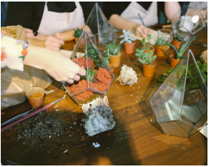

Your Group

Many WIs belong to a group of neighbouring WIs. These groups meet once or twice a year to share a speaker or arrange an activity, outing or demonstration. They are a great way to meet members from nearby WIs and widen your circle of WI friends.

Please ask your WI committee for details of your Group.
Your Federation
Your WI belongs to Surrey Federation (SFWI)

Our role is to support the purpose of the NFWI, and we do this through a wide range of activities that allow members to turn their interests into achievements and their concerns into campaigns. We offer you the opportunity to discover your talents, learn new skills and improve the quality of life in your community alongside all that’s on offer in your own WI.

Your WI

Your WI is a place for fun, friendship, laughter and learning.

Your WI meets a minimum of eleven times a year with an events programme arranged by its own committee. As well as these monthly meetings, most WIs have regular interest groups and activities.

As a member, you take part in electing a committee and President every year, ensuring that each WI is run by the members for the members. The on-going strength and vitality of your WI is important, so please consider helping the committee during your membership.

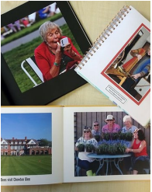

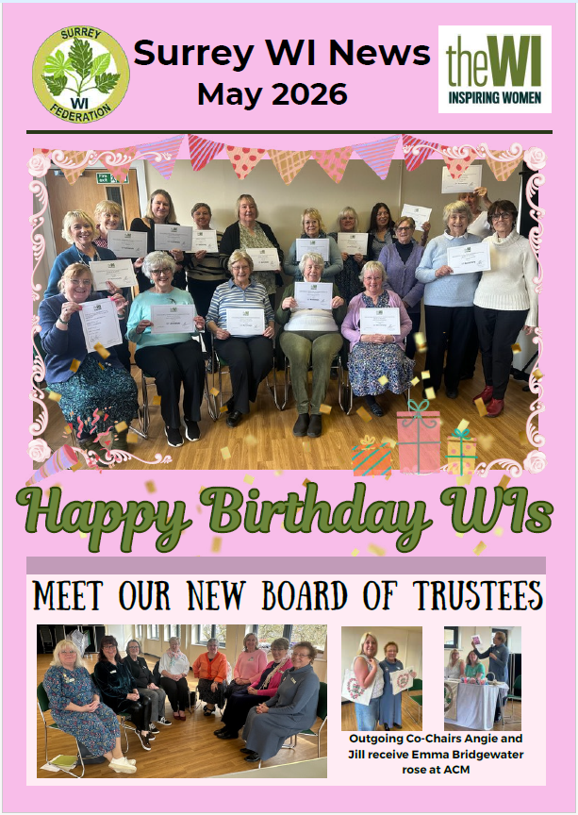

Surrey WI News
The Federation’s monthly magazine Surrey WI News which is emailed directly to you on the first of every month it is also available to download from the SFWI website and is available in hard copy by request for a fee. It will ensure that you are made aware of all the activities and will keep you entertained with articles and stories about WI life in Surrey, along with the Federation’s continually updated social media platforms and website.
Social Media
In addition to SFWI published materials, you may wish to follow us on:

Facebook: Surrey Federation of Women’s Institutes

Instagram: www.instagram.com/surreyfedwi


Website
You can check our website for more information:
www.surreyfedwi.org.uk

Board of Trustees
The SFWI is run by a Board of Trustees with the other Teams delivering a wide range of events for members from all over the Federation.

Up to fifteen volunteers are elected by Surrey WI members every two years to serve on the Board. The Chair or Co Chairs, up to three Vice Chairs and Treasurer are elected annually by the Board members. Further members can be co-opted.

Teams and Working Parties
Each SFWI Team deals with a specialist area as follows:

Skills, Activities and Learning Team (SALT)
Helps members to improve their knowledge and skill in a variety of subjects by organising lectures, demonstrations and courses for all SFWI members to attend. They also arrange outings, trips and experiences to further the aims of the constitution, including in art, literature and sport.

Member Support Team (MST)
This team supports the organisation, growth and development of the WIs and their members through training, positive promotion and visiting WIs.

Resolutions and Campaigns Team (RACT)
This team is a link between NFWI and our WIs and their members. They take the campaigns and resolutions and turn them into workable local ideas for our WIs to engage with and work together to support the National Campaigns.

Office Team:
This is made up of employed staff and volunteers who deal with the day to day running of the organisation. Along with the Board of Trustees, this Team oversee the governance of the organisation.

To help our organisation thrive, we need different ideas from new Team members.



Why not ask to attend a Team meeting of your choice as an observer to discuss if you would like to join that team or the Federation Office, details of which you would find in this pack or by contacting the office via email info@surreyfedwi.org.uk

Edenbridge & Oxted Show (E&O)
The Edenbridge & Oxted Show has its own team of WI members. The team decides on the theme, competition classes, activities, displays and demonstrations which all take place in the marquee. You may find a WI member demonstrating lace making, for example; special activities for children and you will be able to purchase home-made cakes and preserves. The team organises a fund-raising event prior to the show which covers our costs.
WI members support the show by entering competition classes (some of which the public can enter) and visit along with the public to see how their entries fared and admire the quality of craft and other skills on display. WI Advisers are on hand to answer any questions about the WI and recruit new members.

Some of the other regular events etc
Cranleigh Show
Sisterhood Groups (EDI)
Crafty Ladies who meet every other month
Camera Group
Climate Ambassadors
WI Friends



Resolutions
The WI has a rich history in campaigning and these all start with a resolution. These all start with a resolution response to a concern or event that a WI feels strongly about.

Each May, your WI is asked to vote on the NFWI resolutions. These are then taken to the National Annual Meeting for final discussion and a vote. The resolutions that are passed become mandates and campaigning begins.

Over the years members’ concerns have ended in campaigns for example:

- Keep Britain Tidy (1954)
- Freedom from Hunger (1961)
- Free Family Planning (1973)
- Equality of Opportunity (1975)
- The Dangers of Acid Rain (1980)
- Compulsory DNA Testing (1990)
- Care of the Environment (2005)
- Care not Custody (2008)
- SOS for honeybees (2009)
- End Plastic Soup (2017)
- Link Together to Alleviate Loneliness (2017)
- Make Time for Mental Health (2018)
- Get on Board for a Better Bus Service (2019)
- Don’t Fear the Smear (2019)
- End Modern Slavery (2020)
- A Call to Increase Potential Stem Cell Donor Registration (2020)
- See the Signs – Ovarian Cancer (2021)
- Women & Girls with ASD & ADHD (2022)
- Clean Rivers for people & wildlife (2023)
- Bystanders can be Lifesavers (2025)
WI Advisers
Your WI is a place for fun and friendship. To support our WIs SFWI has appointed advisers who have been trained by NFWI. They are linked to the Member Support Team above and their role is to:
- Start new WIs
- Give support and advice to WIs and members
- Help with resolutions
- Run training days on many aspects of committee work
- Visit annual meetings when requested
- Suspend WIs

If you wish to contact your adviser, please email the office on info@surreyfedwi.org.uk and you will be put in touch.
Please see www.thewi.org.uk for full details.

Additional Information
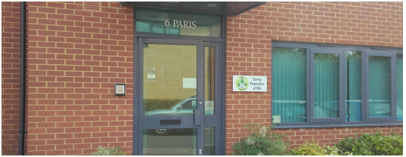

Your Federation Office

The Federation office is situated to the north of Guildford town centre on the site of the former Queen Elizabeth Barracks. This is where the day-to-day business takes place and where the Federation Secretary and staff work closely with the Board of Trustees and sub committees. It is where the beautiful wall hangings are displayed, and the Surrey Centenary Commemorative Book can be viewed. Training courses, Workshops and other events are also held within the building.

Members are always welcome, but please do let us know you are coming first.

Contact Details
Surrey Federation of WIs, 6 Paris, Parklands, Railton Road, Guildford, GU2 9JX

The office is open for visitors between 8am – 4pm Monday – Friday and is closed during weekends and Bank Holidays.

Tel: 01483 233230 (The phoneline is open between 9am – 1pm Monday – Friday)
Email: info@surreyfedwi.org.uk
Website: www.surreyfedwi.org.uk

Dear Member

Welcome! You are now part of the UK’s largest women’s membership organisation, and we are thrilled that you have joined us!

Your WI membership includes:
- 11 Physical and/or virtual meetings. These are a fun and welcoming place to make friends and participate in activities

- Four issues of WI magazine

- The opportunity to involve yourself in exciting local and national campaigns

- Free access to live courses, training, projects and activities through VIA (this is our online learning platform, read more about VIA below. Visit https://via.thewi.org.uk/ to access)

- Opportunities to take part in national activities with our partners, such as England Netball, Three Discovery and many more

- Opportunities to campaign and make a difference such as becoming a Climate Ambassador.

- My WI - the online area for members only

My WI is the exclusive website for WI members, where you can find everything, you need to get the most from your membership – from essential membership information and advice for running your WI, to campaigns and actions. All you need is an email address to get started. Visit https://mywi.thewi.org.uk to access.

More about the organisation:

Campaigns
Our democratic resolutions process means that every campaign we work on comes directly from our membership. After a campaign is launched, the work carried out by the NFWI Public Affairs team would not be possible without the dedicated commitment from members.

VIA
We all have a natural drive to explore, learn and grow; lifelong learning allows us to improve our knowledge, quality of life, it gives us a sense of worth, inspires us to achieve our personal goals, take on new challenges and discover new passions. VIA offers a rich variety of learning experiences for WI members and by recognising the continual changes that we all face; resulting in a learning journey that is accessible, flexible and inclusive which empowers all women and girls to reach their goals, regardless of their learning adventure.

New member survey
This survey enables the NFWI to build a clear picture of the WI membership and only takes 5 minutes to complete. Completing this survey is optional but helps us to better understand you, our membership, so we can ensure projects, procedures etc. are developed with you in mind.

So please tell us all about yourself so we can make sure WI activities are tailored for our members’ needs and that you have the best membership experience.

The new member survey is only available online. To complete the survey, go to https://www.thewi.org.uk/new-members-survey.

Contact us
Your federation and the NFWI are always here to help, so if you have any questions let us know. You can contact the NFWI Membership and Engagement Team via telephone: 0207 371 9300 (Ext. 2021) or via email: membership@nfwi.org.uk

With best wishes for a happy and enjoyable WI membership
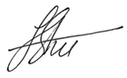
From Jeryl Stone, the NFWI Chair, on behalf of all NFWI Staff and Trustees
The National Federation of Women's Institutes of England, Wales, Jersey, Guernsey and the Isle of Man 104 New Kings Road, London, SW6 4LY
Charity number: 803793 | Company number: 2517690


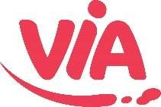

www.via.thewi.org.uk

On Monday 9 February 2026, we took the next step in our learning journey, moving from the
WI Learning Hub to VIA – our new, permanent home for learning. Built on the foundations of Denman’s legacy, VIA has been designed with learners in mind and aims to offer a more accessible and engaging digital experience.

To help make things easier, we’ve included answers to some of the most common questions below, along with links to our FAQs and Help Guides that you may find useful. These resources, together with our new ChatBot, should help answer most queries and support users as they get started. However, if you can’t find the information you need, please don’t hesitate to contact us directly.

Our FAQ section is here to make everything simple and stress-free
https://via.thewi.org.uk/faqs

Whether you need help booking a course, joining a session, exploring accessibility options, or resolving a user issue, you’ll find clear answers and step-by-step guidance all in one place.

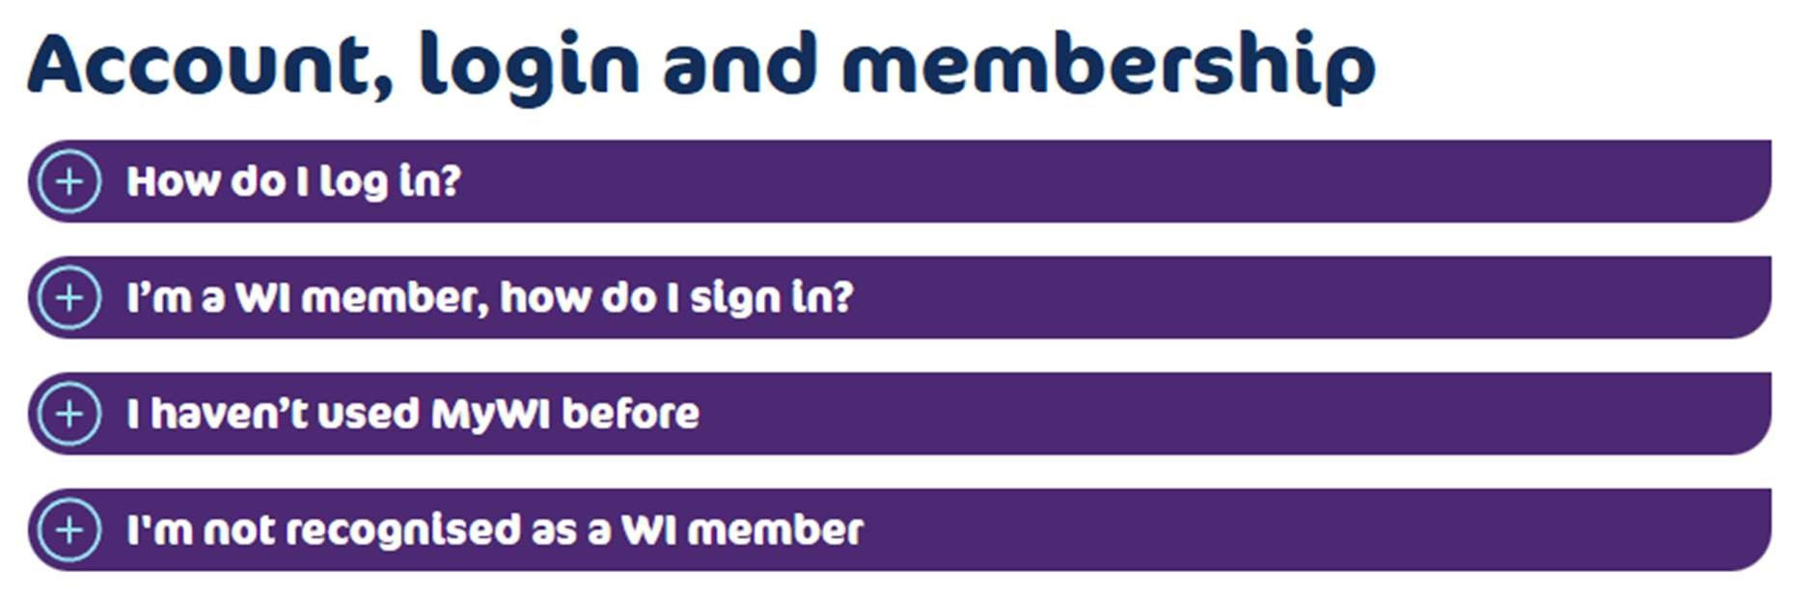

Step-by-step guides to support you using VIA
https://via.thewi.org.uk/help-guides

These step-by-step guides plus our new video, will help you find your way around VIA. From logging in and booking courses to accessing your learning, each guide walks you through what to do, one step at a time.

I’m a WI member; how do I sign in?
Members of the WI are not required to set up a new account. Please encourage your members to follow these easy, step-by-step instructions:

- Click on the ‘Login’ tab (top right-hand of screen)
- Either click on the WI logo, or use the ‘Login with WI’ button
- If you’ve already activated your My WI account, you’ll be promoted to enter your My WI login details.
- If you haven’t accessed My WI before, enter your mail then click ‘Forgotten password’, and follow the instructions to continue.

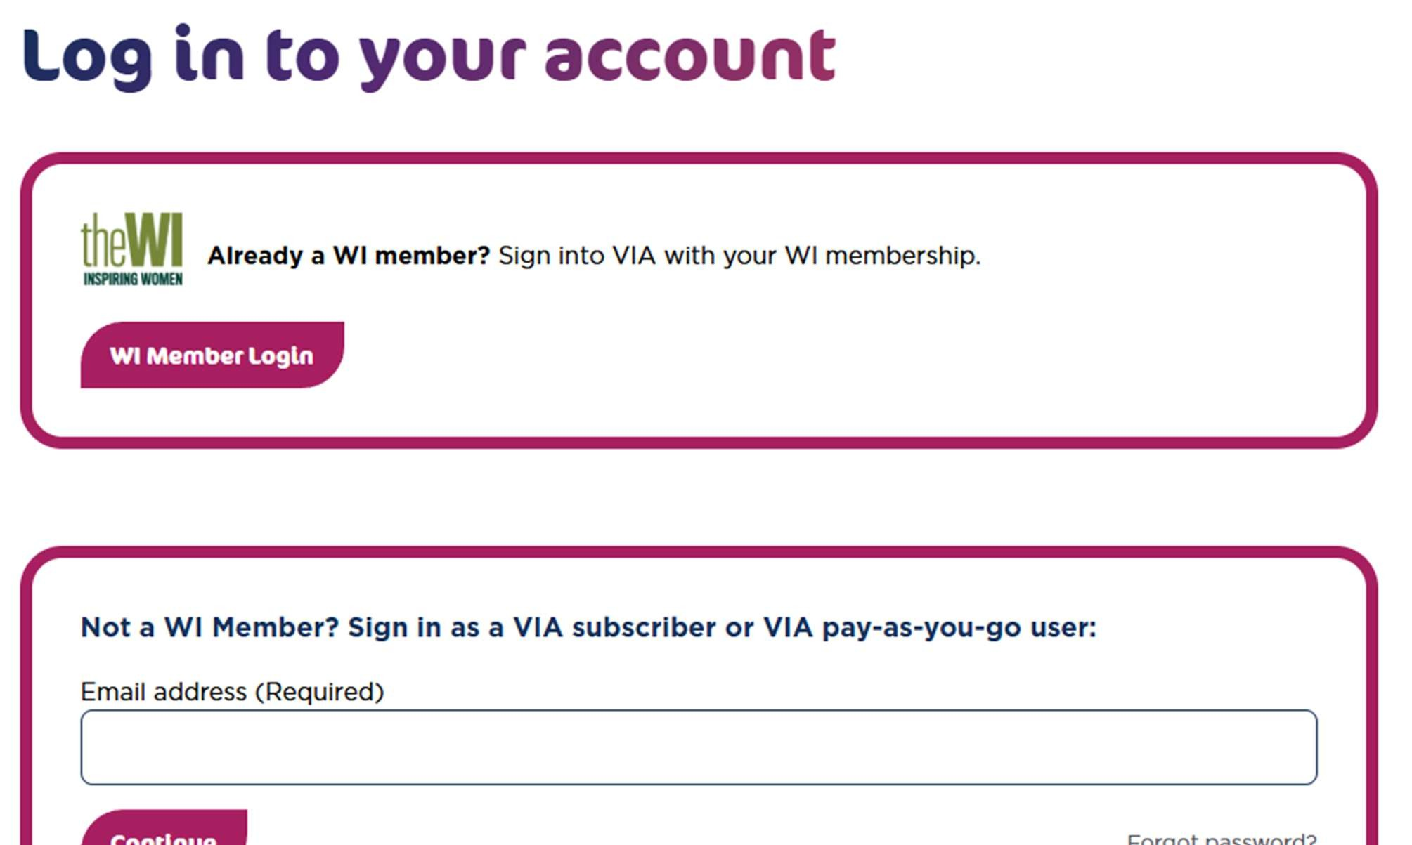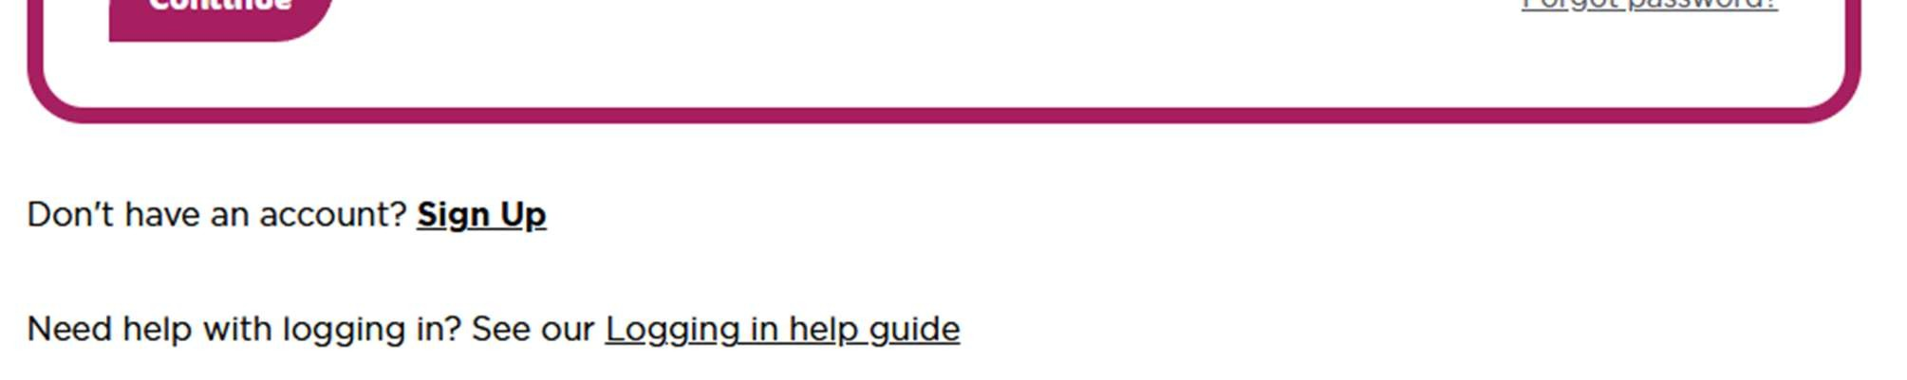

Why am I being charged £3.99 a course?
As with the WI Learning Hub before, WI members will continue to access the majority of our courses for free (apart from those clearly advertised with a fee, such as our premium courses). If your basket is showing a value, please clear your basket, log out and make sure to follow the ‘I’m a WI member; how do I sign in?’ instructions. If you have signed in through the correct process, it will recognise you as a member and automatically remove the charge at checkout.

Do I need to re-subscribe to the newsletter?
No, your details will have been transferred over, so you can continue to enjoy our weekly newsletter and stay up to date with courses, events and activities, stress-free!

You’ll find the newsletter sign-up link on the footer of the main page.

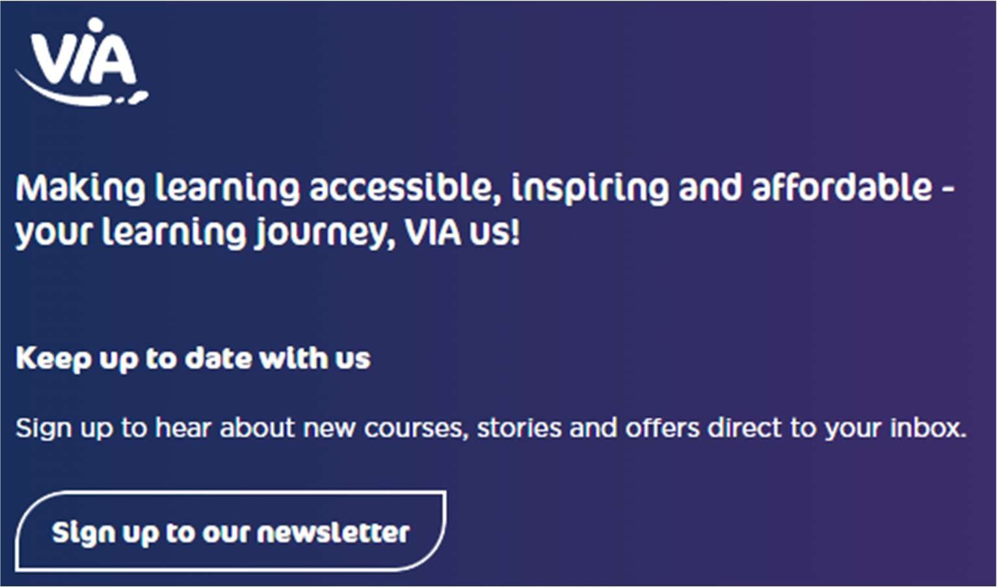

What will I find on my dashboard?
Your personalised dashboard is the heart of your VIA experience, designed to make learning simple, inspiring and easy to manage.
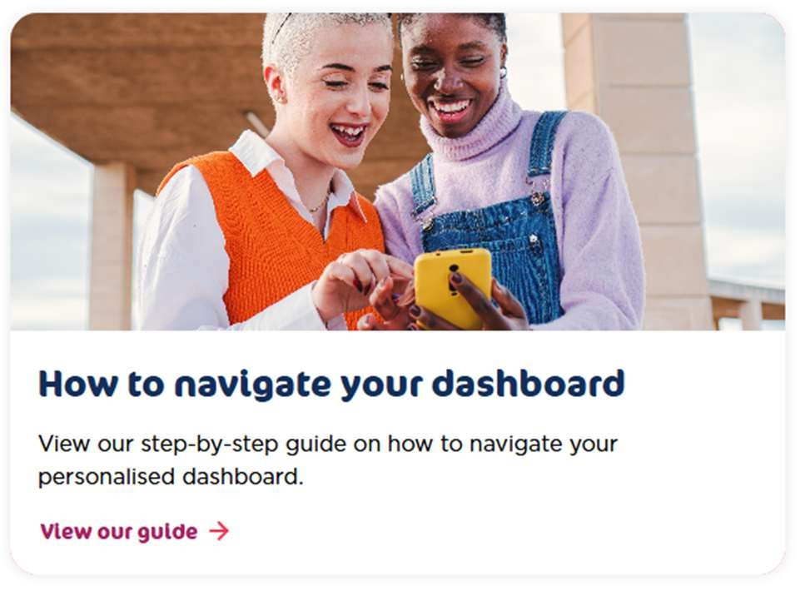
From the moment you log in, you’ll see everything you need in one convenient place including the courses you’re enrolled in, upcoming sessions, and any learning you’ve already started so you can pick up right where you left off. You can also revisit recordings, download course materials, save courses you’re interested in, and update your personal details and learning preferences. It’s a smart, personalised space created to help you explore, organise and enjoy your learning journey on VIA.

VIA means 'by way of' or 'through' and that's exactly what it represents. Every learning journey happens VIA us and has been designed to guide, support and connect learners as they explore new ideas, build skills and move towards their goals, whatever stage of life they are at.

NFWI Charter

- Introduction
This document outlines the principles of the partnership between the NFWI and its members and explains what members can expect from being part of the NFWI. It also outlines what NFWI staff can expect from members. This is a living document and will be regularly reviewed to ensure it reflects feedback from members and changes to resourcing at NFWI.

The WI is based on the ideals of the fellowship, truth, tolerance and justice. In all that we do, members and staff are expected to demonstrate and operate with these values.

- Principles
The partnership between the NFWI and its members is based on the following five principles.

  - Support
The three tiers of the NFWI (WI/federation/NFWI) exist to ensure all members are effectively supported and can get the very best from their WI experience. This relationship is one of partnership and shared purpose. All members should feel able to contact the NFWI for advice and guidance.

  - Feedback
All members, at any level of the organisation should feel able to share views, comments and feedback on their experience and this is actively encouraged to support the ongoing development of the organisation and a culture of continuous improvement. Feedback will be received in an open and constructive manner with formal follow-up as appropriate.

  - Structure
The SFWI has a three-tier structure to ensure effective and timely support is available. WI specific enquiries should be directed to the relevant federation in the first instance. These will then be escalated to the NFWI if necessary.

  - Communication
All views, comments and feedback should be shared respectfully and appropriately and within the values of the NFWI.

Members can phone, write or email to share their feedback. NFWI staff have individual email addresses, but there are also a number of general email addresses if you do not know the name of the staff member you wish to contact.

  - Respect
All members and staff have the right to respect and to feel safe. Offensive or disrespectful behaviour will not be tolerated and may end in disciplinary procedures (staff) or barring of an individual from contact with the NFWI (members). The same true for members, who will always be treated with respect and courtesy whenever they contact NFWI; the relationship is one of mutual respect and tolerance.

- Response
The NFWI operates a target response time for all enquiries received. This is outlined below. This response time is published for transparency and to manage expectations. This is the standard that members can expect and are entitled to challenge this if necessary. Individual NFWI staff teams operate target response times which vary based on the capacity of each team and the average volume of enquiries received.

Whilst the NFWI aims to provide an immediate response to last minute requests when it can, this will not always be possible. Where information is required and this is known in advance, we ask that you provide as much as possible. If an enquiry is an emergency, then this should be directed by phone to the NFWI London Office.

With enquiries on behalf of multiple individuals, such as those from a whole WI or a WI committee, we ask that the enquiry is sent only once. Multiple enquiries from different individuals on the same topic can slow down our ability to respond to enquiries within our timescales.

- Response times
The NFWI aims to respond to all enquiries – regardless of the method of communication – within 10 working days of receipt.

THE NFWI CODE OF CONDUCT

- Introduction
The WI is an organisation centred on friendship, campaigning, education and fun. We are a place for all women where members are welcomed, supported and able to fully enjoy their membership and utilise all the opportunities that comes with it.

- WI Members
WI members must:

- Demonstrate the WI values of truth, tolerance, justice and fellowship
- Be kind and considerate towards others
- Use inclusive and polite language
- Share views, comments and feedback respectfully and appropriately
- Respect others at all times
- Feel able to make mistakes and learn from these
- Raise concerns and complaints
- Comply with applicable WI, federation and NFWI policies
- Ensure the WI is place for all women by welcoming new members
- Avoid bringing the organisation into dispute

- Trustees
WI and federation trustees must:

- Act in the best interests of the WI as a whole including federations and the NFWI
- Respect and maintain confidentiality
- Support the decision of the majority
- Work in partnership with each other
- Act within the governing documents and the law
- Manage conflicts of interest effectively
- Ensure concerns and complaints are followed up appropriately
- Carry out their role with the WI vision statements in mind; bold and inspiring, growing and relevant, flexible and inclusive

- Unacceptable behaviour
The NFWI has a zero-tolerance policy of discrimination of any type, including racism, homophobia and transphobia and of any behaviour that intends to cause distress to another. Any such behaviour must be reported and will be investigated.

- Resources
This code must be read alongside the following NFWI policy/guidance documents:

NFWI Charter
NFWI Complaints Policy
NFWI Equality, Diversity and Inclusion Policy
NFWI Social Media Code of Conduct

WI Member Reasonable Adjustments Form

WI membership is open to all women. We do not ask members any personal questions as part of the joining process and are committed to ensuring all members are treated fairly and equally whatever their background or individual circumstances.

Completing this form is optional and members do not need to complete this form to become a member of the WI. This form accompanies the WI Member Registration Form and offers members the opportunity to share any reasonable adjustments they need with the WI Committee.

Reasonable adjustments aim to minimise or remove the disadvantages experienced by those with disabilities. Examples of reasonable adjustments include:

- Providing a sign language translator at physical or virtual meetings and events.
- Ensuring there are accessible toilets.
- Allowing members who may feel anxious to arrive early and get settled before a meeting or event begins.
- Taking steps to ensure that members with dementia are able to arrive at and
leave the meeting or event venue safely.
- Keeping seats at the front reserved for those with hearing impairments.

What is reasonable depends on the circumstances of each individual case including:
- The type of disability.
- How practicable the adjustments are.
- How the adjustments would overcome the disadvantages experienced.
- The size of the organisation, the resources available and the cost of the
adjustments.
Each WI has its own profile on the main website (www.thewi.org.uk) which includes accessibility information. However, a WI may still need to make reasonable adjustments. Please see the NFWI Equality, Diversity and Inclusion Policy for more information on reasonable adjustments.

This form can be completed at any time. This information will not be shared with anyone outside the WI Committee.

- First Name:

- Last Name:

- Contact information:

- Preferred method of communication (email/phone/WhatsApp):

- Are there any reasonable adjustments that you need and would like the WI Committee to be aware of? Please provide information.

Members who wish to disclose their needs relating to autism and/or Attention Deficit Hyperactivity Disorder (ADHD) can do so using this form or the form found here (https://mywi.thewi.org.uk/public-affairs-and-campaigns/current-campaigns/thinking-differently). This can be completed and handed to a WI Committee Member.

Thank you for providing this information which will be used to consider any additional needs any member may have, and to adjust where possible with the aim to make this WI as inclusive as possible. The information will only be used for this purpose and will be securely disposed of when no longer needed for this purpose.

This information will not be shared with anyone outside of the committee of [insert name] WI.

If you change your mind, you have the right to withdraw this information at any time, simply let us know via email at [contact information]. You also have the right to view or alter this data at any time.

If you have any concerns about data protection which cannot be answered by your WI, you can also contact the NFWI Data Protection team by emailing dataprotection@nfwi.org.uk.
Signature:

INSTRUCTIONS
WI member: On completion, please hand this form to a WI Committee member.

WI Committee member: This form must be stored securely and the information provided used to ensure, where possible, the member’s needs are met. We recommend deciding as a WI Committee who needs to have access to this data and keeping this as limited as reasonably possible. If and how the member’s needs can be met, must be communicated to the member.

Surrey Federation of WI’s
List of Acronyms Used

ACM | Annual Council Meeting
ACWW | Associated Country Women of the World
AFM | Autumn Federation Meeting
BOT | Board of Trustees
SALT | Skills Activities & Learning Team
EDI | Equality, Diversity, and Inclusion
E&O | Edenbridge and Oxted Show
EPF | Event Planning Form
IFE | Independent Financial Examiner
MCS | Membership Communication System
MST | Member Support Team
NFWI or National | National Federation of WIs
RACT | Resolution And Campaign Team
SWIN | Surrey WI News
WIAs | WI Advisers

