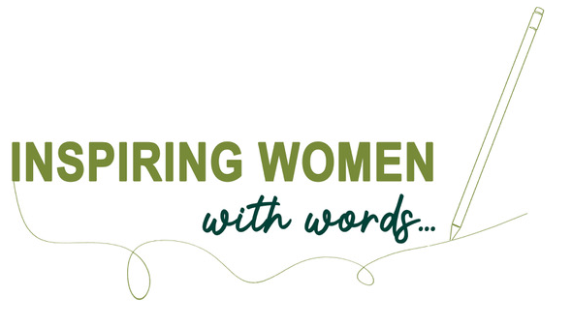
WI members are invited to write a letter explaining how the WI has influenced or impacted them as an individual, and how it has helped them become the woman they are today.

Members should consider how their letter would inspire other women and girls and encourage them to join the WI. Entries must be no more than 500 words; the letter can either be left open or addressed to a particular individual.

Competition Schedule
- Each entry must include a total word count; entries with over 500 words will not be accepted. It is the responsibility of the individual member to ensure that their entries submitted have the correct word count.

- Members can submit as many entries as they wish.

- Entry fee is £5 per entry. Critiques are optional and must be selected and paid for as an additional fee. Cost for this option is £10 (entry fee and critique) per entry.

- Requests for late entries to receive a critique by the judges, outside of the competition timeframe, will not be granted.

- Entries cannot be acknowledged. All entrants will be informed of the results via email (unless postal letter is specifically requested). Federations will be informed approximately 1 week after the entrants and the results will go live on social media and My WI a further 1 week later.

- Please do not send your entry to your federation office; federations will not be expected to forward entries to the NFWI, nor return to the writer.

- All entries must be accompanied by a completed Competition Entry Form.

Timescale
Deadline for entries to be submitted for judging: 28 July 2023
Results to be announced to entrants: by mid-October

Electronic Entries
Please email your entry and Competition Entry Form to activities@nfwi.org.uk Please ensure that your entry remains anonymous (you can sign the letter off with your initials, but for judging purposes, do not include your name, WI or federation).

Postal Entries
The preferable method of entry is via email; however, we appreciate this is not an option, or favoured by all, and postal copies are still welcomed.

If you would prefer to submit your entry by post, please submit 3 copies of your entry. Please ensure that your name, WI and federation are only written on the first copy; the remaining 2 copies must be anonymous (as stated above, you can sign the letter off with your initials, but for judging purposes, do not include your name, WI or federation). A Competition Entry Form must be completed and attached to the top copy of your entry.

Please send postal entries to:

NFWI Education and Training
The Lambourn, Wyndyke Furlong, Abingdon, OX14 1UJ

Prizes
The winner will be presented with the *Lady Denman Cup at the Annual Meeting 2024.

Book tokens will also be given as prizes: 1st prize, book tokens to the value of £75; 2nd prize book tokens to the value of £50 and 3rd prize book tokens to the value of £30.

Who was *Lady Denman?
Raised in an openly feminist and politically active house, Gertrude Mary Denman (1884-1954) recognised very early in life that her family wealth and status in society must be used to serve the greater good of the community. Her home, Balcombe Place, near Haywards Heath would become the Women’s Land Army administrative headquarters through the duration of World War II.

Gertrude, (known as “Trudie” in close circles), was married to Thomas Denman (1874-1954), 3rd Baron Denman and fifth governor-general of Australia (1911-1914). During her time abroad she held many national and international leadership roles within women’s organisations. She represented a growing exchange of progressive ideas regarding women’s place and roles within society.

In Britain, after serving as chairman of the subcommittee of the Agricultural Organisation Society, Lady Denman helped found the Women’s Institutes (WI) in 1916. The institutes became self-governing when under Lady Denman’s supervision the National Federation of Women’s Institutes (NFWI) was formed in 1917. She was elected its first president and was re-elected to this position every year until her retirement in 1946.
