Federation Treasurer Report to SFWI Annual Council Meeting 20 March 2023

This is my report for the financial year from 1st November 2021 to 31st October 2022.

The results for the year to 31st October 2022 can be found on page 10 onwards in the ‘Annual Report including Financial Review’. The delegates should have a copy of this. The Statement of Financial Activities for the year is shown on page 10, the Balance Sheet is on page 11 and on page 12 there is a comparison between actual and budgeted figures for the year to 31st October 2022. The budget for the year ended 31st October 2023 is on page 13.

This is the third year the activities of the Federation have been impacted by Covid-19. The program of events was not a full as in the years before Covid-19 and many of the events we held were not at capacity. Several WIs have suspended, but due to new members joining WIs as a Federation we saw only a small fall in our overall membership numbers.

Although we have had a challenging year, the Federation is in a strong financial position.

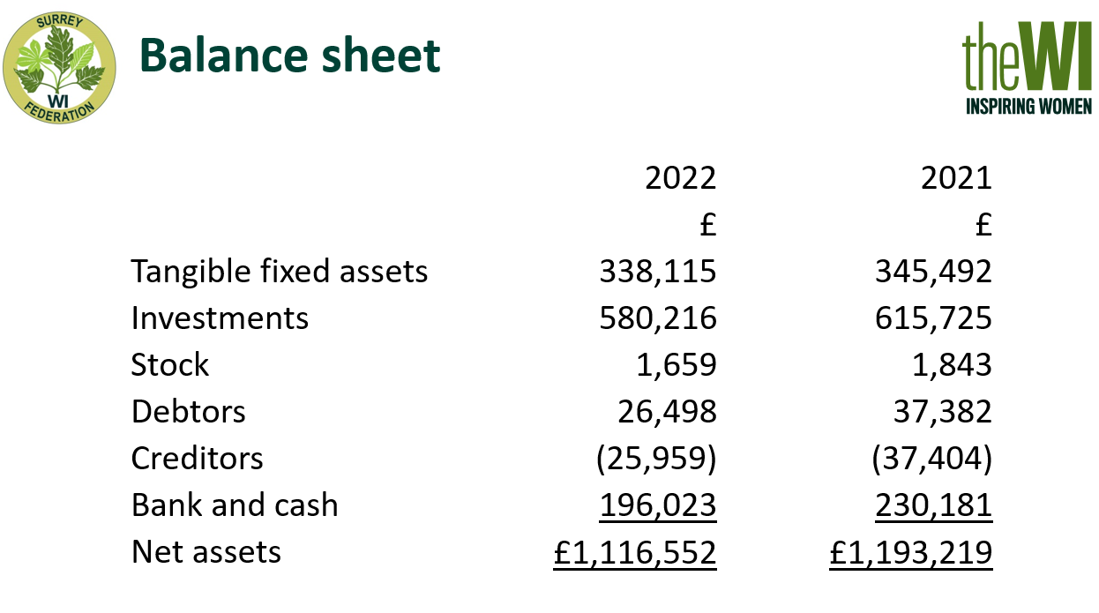

The Balance Sheets for 2022 and 2021 are shown here. This years is on page 11 of the annual report.

As you can see our investments, which are held in shares and unit trusts on the UK stock market, have dropped in the year. The decrease is almost entirely due to the fallout from the budget when Liz Truss was our Prime Minster and the markets fell by over 10%. This year we moved £35,000 from our bank account onto the stock market to give us higher investment returns, which is the main reason for the decrease in the money held in the bank. Our investments provided us with income of about £25,500 this year, which is a return of about 4%, far in excess of anything we can get from a bank. Investment income is part of the overall income used to fund the running of the Federation.

The fixed assets are our building, it’s furnishings and our office equipment. Owning our building means that we have costs to maintain it, but we do not have to rent office space or rooms for committee and board meetings or for many of our workshops.

Stock is the items we hold for resale and are valued here at cost. Much of this is the Surrey Federation logo badges and NFWI accounting stationery.

Debtors are where we are owed money. This includes any dividends paid on our shares to our stockbrokers, but they have not yet forwarded to the Federation, any money invoiced to WIs but not yet paid, which was mainly AFM tickets and any items prepaid like hall hires for events due to take place after the year end.

Creditors are where we owe money to others. This includes any payroll taxes and pension due on the October staff salaries, any subscriptions to be forwarded to NFWI, and expenditure where we are expecting a cost but not received the actual paperwork by the year end. It also includes any income we have received in advance for events or trips after the year end so that all income and expenditure are accounted for in the year in which the event occurs.

Our bank balances at the end of October are always quite high as we have to hold sufficient free cash to get us through to the receipt of subscription income in the next year. The earliest we will receive any subscription income is April. Please try and pay us in April as we have to pass on to NFWI their share of subscription income May. At the yearend we should hold enough money in the bank to cover up to nine months of salaries and other costs, although in all recent years we have held more than this.

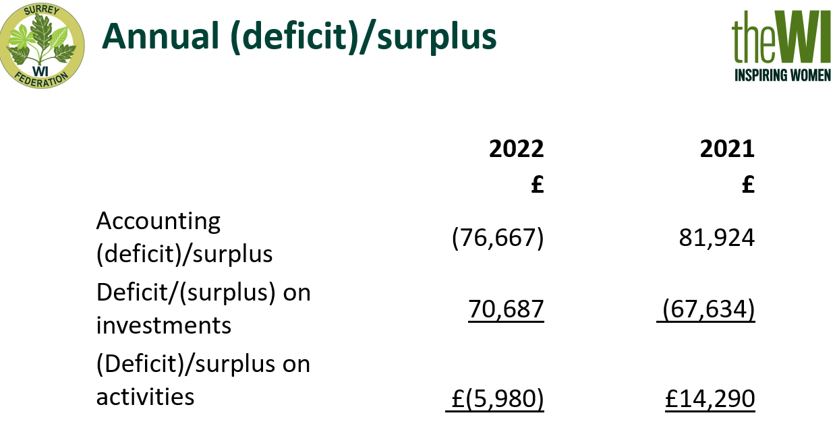

The overall results show a large deficit for the year, but most of this is due to the decrease in the value of our investments. As you can see from the slide without these our results show only a small deficit this year of £6,980 compared to a surplus of £14,290 last year. The movement in the value of investments is not an item that we can budget for. The Federation controls the movement in the value of our investments as much as possible by having a portfolio of low to medium risk investments, which means the movement in our portfolio tends to broadly follow overall stock market fluctuations.

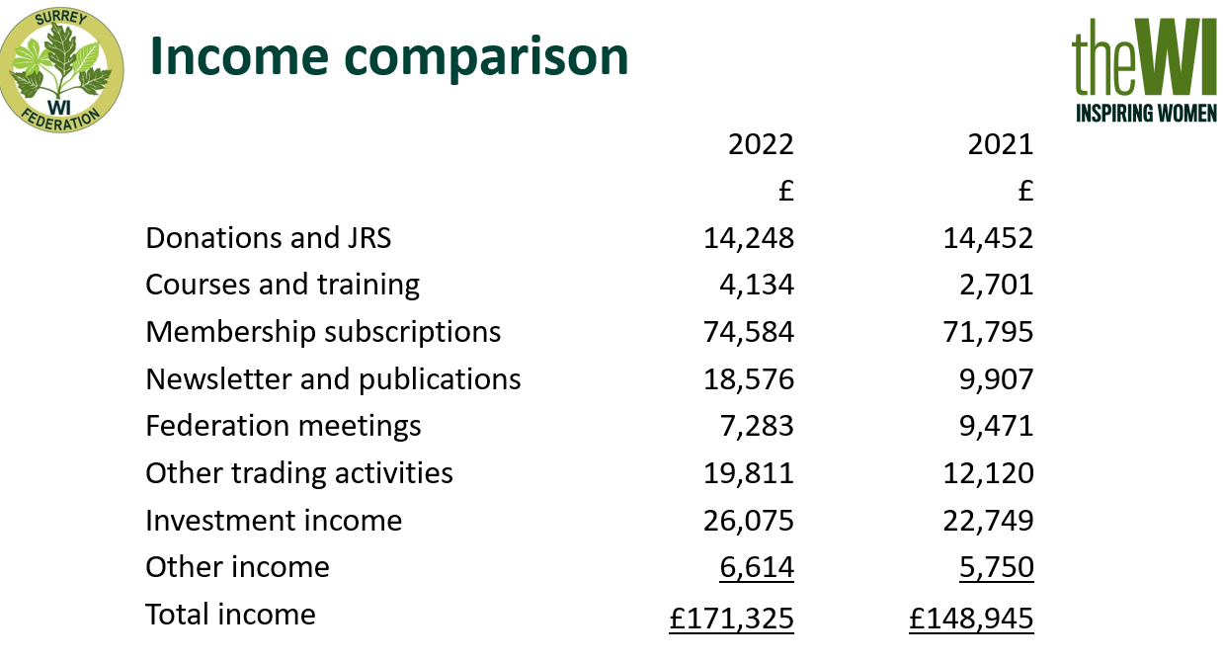

Our income, shown in the Statement of Financial Activities on page 10 of the annual report, has seen a rise this year. This year we saw an increase of 15%, so are back to our 2020 level, if not yet to pre-covid-19 levels of nearly £200,000, but with fewer members and no Surrey at Denman weekend that is unlikely to happen.

The donations amount is mainly the money from suspended WIs that has been passed to the federation and any legacies. There was no job retention scheme income this year but there was some in 2021 so it still referred to in the heading.

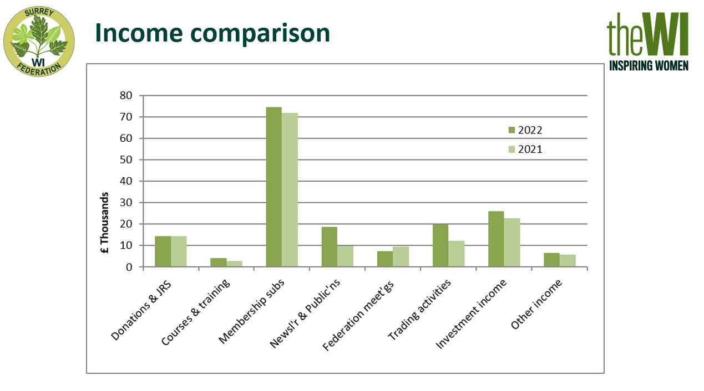

The main increases this year are in courses and training as we held more committee workshops and the Home Economics committee were able to resume a fuller program of activities, in newsletters as there was a full year of hard copies available and in trading activities as the Events, Leisure and Fundraising committee ran more activities. For many activities the cost increase in a similar proportion to the increase in income so they do not affect out overall result dramatically.

By far the biggest source of income for the Federation is membership subscriptions. Although our membership levels have dropped slightly, we have seen an increase in our income, which is at least partly due to undertaking an exercise collect in subscriptions so the numbers on the NFWI membership communication system agree with the subscriptions passed to Federation, so lot of pro rata subscription have been passed over to Federation sooner this year. It’s this timing and a higher percentage of our members joining in April and so not taking advantage of the pro-rata rates that has led to the increase in membership income. Membership income was 43% of our overall income this year, which is close to the 41% it was pre covid-19.

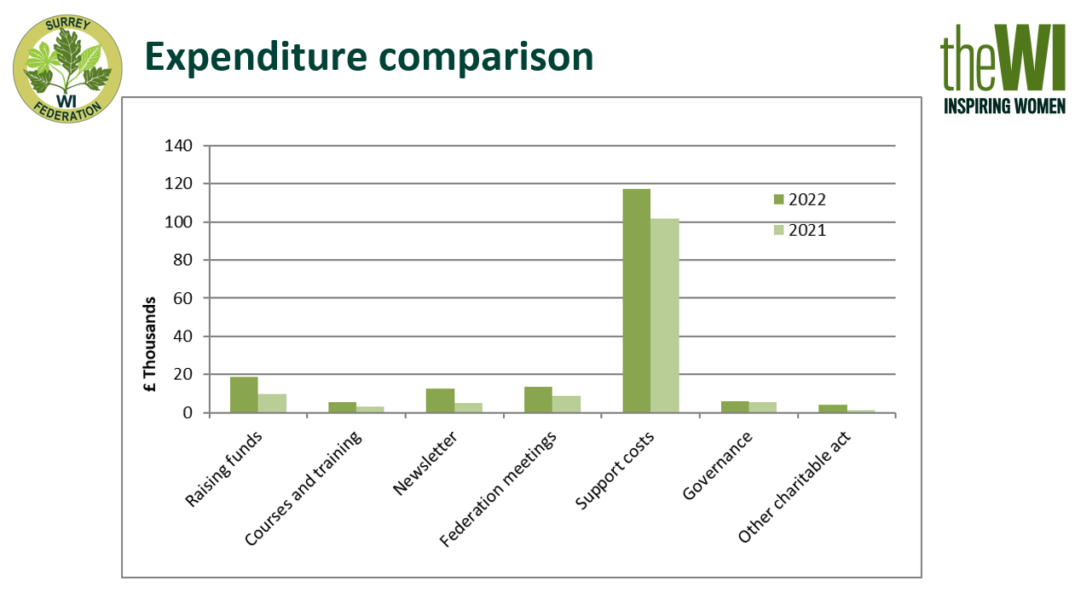

We saw an increase in expenditure in the year from £135,000 to £177,000 which is a rise of 32%. Most of the rise is due to increased support costs, by far our largest area of expenditure, which I will cover later in more detail.

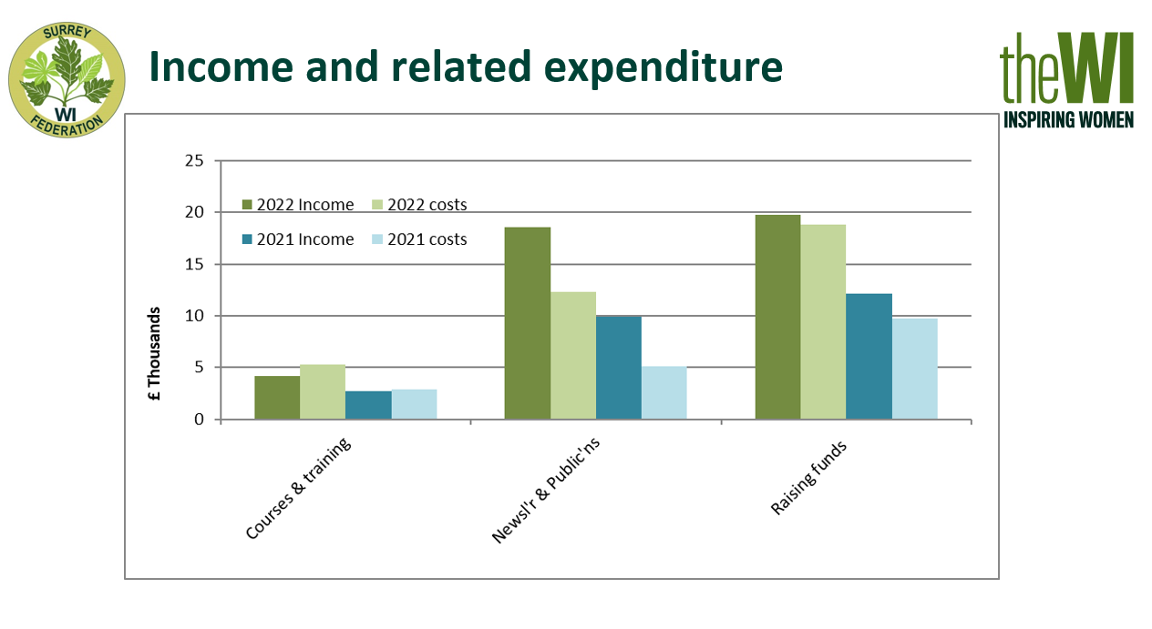

This slide shows the income and costs for each of courses and training, newsletter and publications and fundraising events. I’ve added 2021 in blue. You can see that although we have generated almost twice the income in all three of these categories this year, costs have increased by a proportional amount, so the increased activity does not produce much additional surplus for the Federation. These costs do not include any allocation of staff time or office costs. e.g. the postage cost for the copies of Surrey WI News sent from the office is included in postage and not as a cost of the newsletter.

There are two main sources of income within Newsletter and Publications. One is the yearbook which rose by £200 this year to £3,200. Surrey WI news has been back in hard copy for over a year so there is a full year of income at just over £15,000. This is lot lower than the £22,000 we received in the year before Covid but is not unexpected as we have over 1,000 fewer members and more of the members are now reading online. We are currently distributing 150 fewer copies per month than this time last year, and 1,800 fewer than before lockdown, which is a substantial drop in income. We have not increased the price for additional copies or postage of Surrey WI News for many years. With rising postage and courier costs we might have to increase the charges in the next year, but as Surrey WI News is such an important method of communion within the Federation I want to avoid doing so if I can.

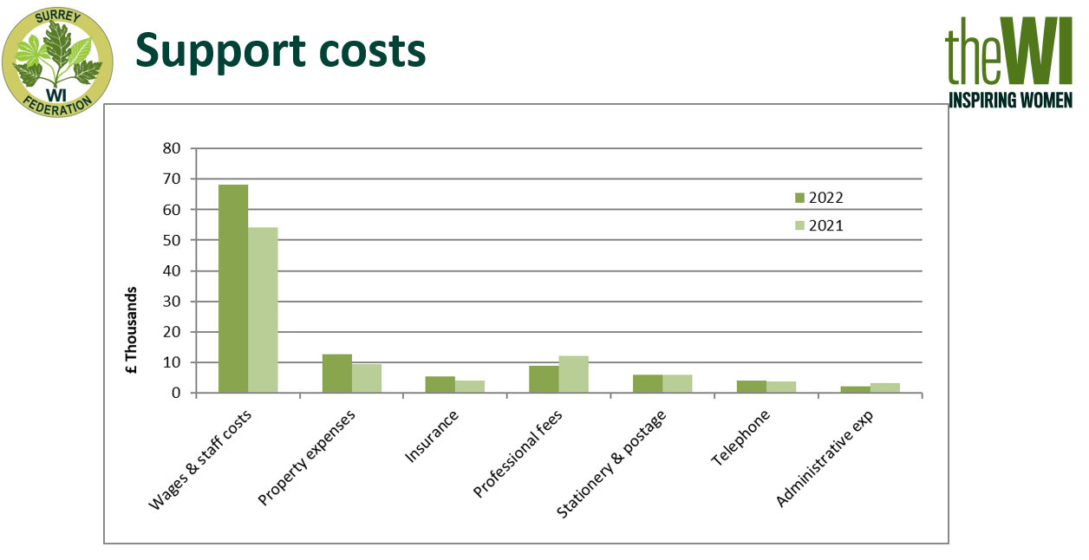

Support costs are what we have to pay to maintain the building and to run an office, including paying our staff. These costs do not vary much based on the number of events we run and are therefore fixed costs. The largest part our support costs is staff salaries. This has increased this year because in January 2022 we took on Ruth as our digital administrator to enable the Federation to roll out the use of office 365 to WIs and to all Federation volunteers. Salary costs includes Pensions and National Insurance costs as well as the actual salary.

The Board members and the office staff strive to keep all costs to a minimum, including regularly reviewing contracts to ensure we are getting the best possible deals. As we own our property, we will always have property running and maintenance cost, including the service charge for the Parklands Estate. The service charge includes costs like the gardening and rubbish removal which are organised centrally for the whole estate.

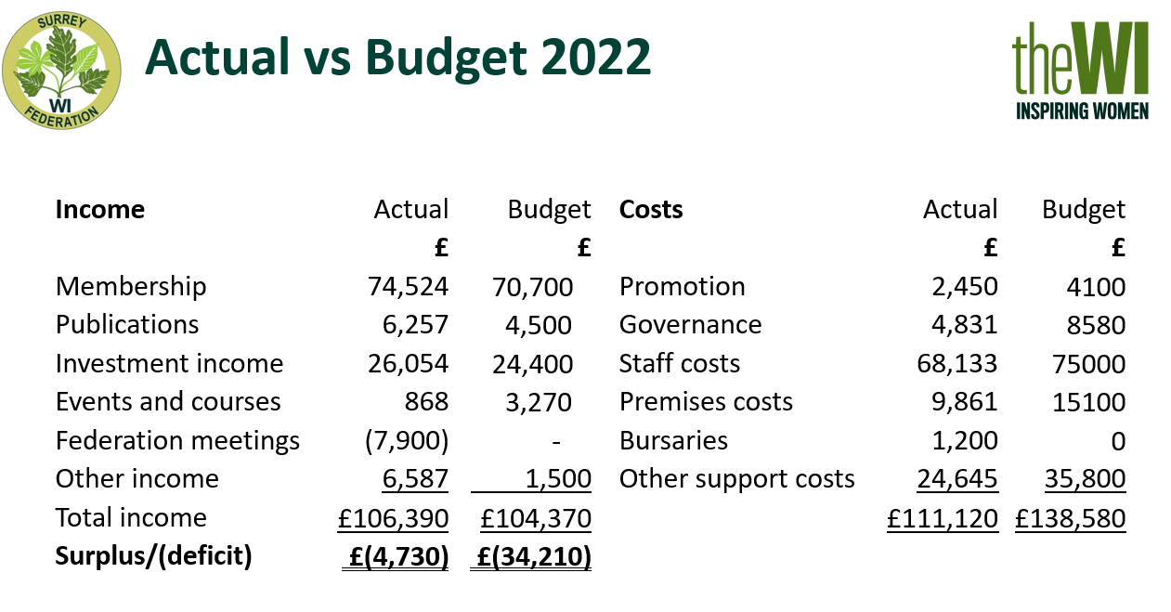

The Statement of Financial Activities on page 9 of the annual report includes the movements on our designated funds, but the budget comparison on page 11 only includes movements on our free funds, which is why these two do not show the same figures. Also, these are the net figures showing the surplus or deficit in each area and not the gross amounts received in and amounts paid out. The Federation performed much better than budgeted this year. You will see that most areas show fluctuations from budget and the main areas are:

Other income - this is because in the year we received a legacy from the estate of Joy Morgan which will be used for bursaries once the Denman Trust is fully set up. Legacies cannot be budgeted for.

Staff costs - the main reason this is lower than budgeted is that we allowed for a full year of salary for our digital administrator and also because HMRC increased the Employer’s National Insurance rebate this year.

Premises costs and other support costs - both are considerably lower than budgeted due to a change in how we account for IT replacements and building maintenance. Both of these have previously had money put aside each year and this pool was drawn on as items need purchasing. It has been decided this year to dispense with this complicated method of accounting and put all costs in the accounts for the year in which they arise. The total on these pools written back was over £12,000 which was a large boost to the reduction in our deficit this year. This was not a consequence I thought of when I requested the policy change, but I’m not complaining about it.

The Newsletter income was above budget as I was too pessimistic about how many would want to read the hard copy. We have more members than predicted. We spent less on governance, mainly due to the National Council meeting being virtual again and with the return of a physical national annual meetings in Liverpool I was finally able to unravel several years of accumulated transactions on our ledgers relating these meetings.

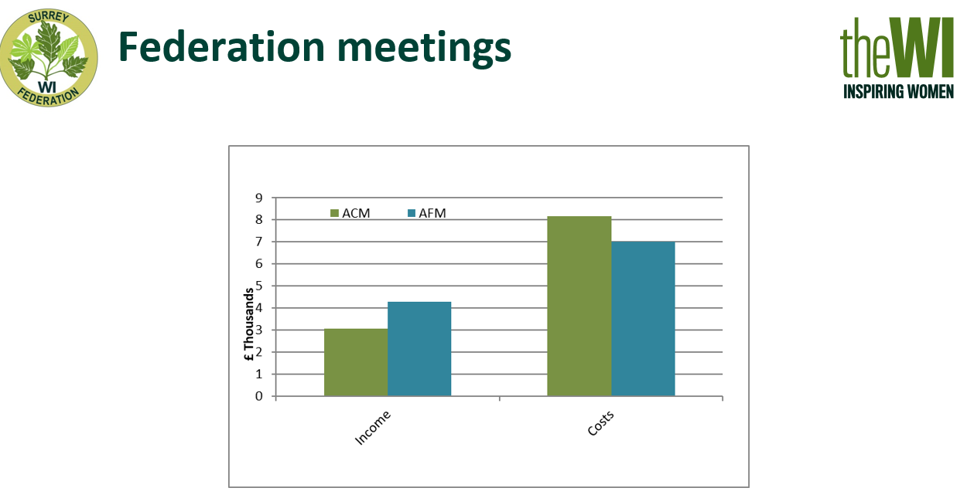

The biggest difference between budget and actual is Federation meetings. We made total deficits between the March 2022 Annual Council Meeting and the October 2022 Autumn Federation Meeting of nearly £8,000. The ACM is in green and the AFM in blue and for both meetings you can see how much taller the cost column is than the income column. We did not have enough attendees at either meeting to cover the cost of renting the building here, let alone paying for the costs of speakers and travel. As a board we know the many members have been reluctant to attend large meetings following Covid and many who used to attend regularly have had significant changes in their lives in the last three years and so cannot attend any more. We have to hold an Annual Council Meeting, but the Autumn Federation Meeting needs to be a fundraising event so as a Board of Trustees we have made the decision not to hold a AFM in Autumn 2023, with a view to bringing it back in different format in 2024.

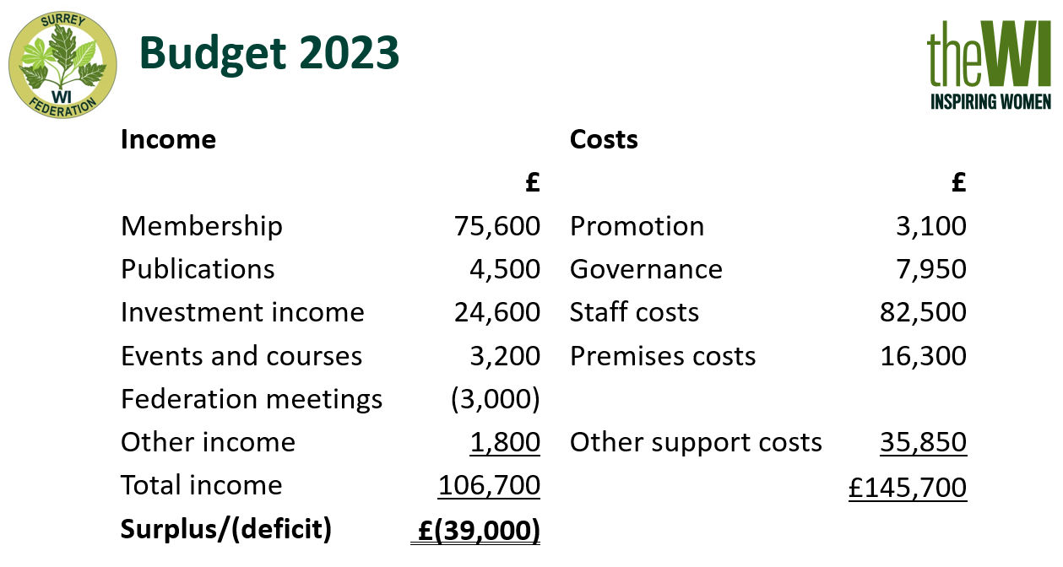

The budget for 2023 shown on page 13 was mainly prepared in September 2022, so was largely prepared before we had the final figures for the year to 31st October 2022, which was also before the board made the decision to cancel the Autumn Federation Meeting. I provided each committee with my draft budget for them and so I hope this involvement means their targets are realistic. The potential deficit is large, but the Board hope that by using some of our savings in this year will help us to work towards increasing and retaining membership and being a to put on more training events so we can build a stronger federation for the future.

I could not do the role of Federation Treasurer without the office staff, in particular the Federation Bookkeeper who wades through the seemingly endless bits of paper I put in her in tray or forward by email. She keeps the accounting records up to date on Sage as well as dealing with queries as they arise.

