**LADY DENMAN CUP**

**COMPETITION 2021**

***“Let me show you what a woman can do!”*** 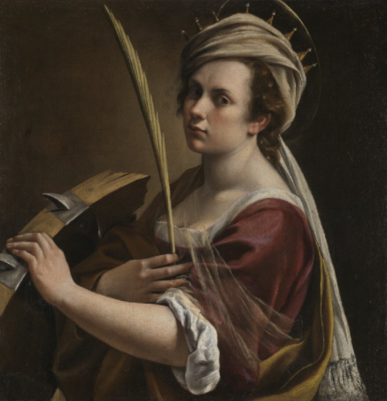

**Schedule**

Using no more than 500 words, The Lady Denman Cup Competition 2021 invited WI members to submit a piece of creative writing using Artemisia Gentileschi, Self Portrait as Saint Catherine of Alexandria, about 1615-17. @The National Gallery as inspiration with the title “Let me show you what a woman can do!”

This could be presented in the form of a poem, fictional story or factual piece.

The NFWI received 105 entries from 50 federations and the final results were…

|  |  |  |
| --- | --- | --- |
| First | Janet Gray | Devon Federation |
| Second | Hazel Allen | North Yorkshire West Federation |
| Third | Romaine Barclay-Kim | Northumberland Federation |
| Highly Commended | Suzane Simmons | Buckinghamshire Federation |
| Highly Commended | Jane May | Oxfordshire Federation |
| Highly Commended | Jenny Cawthorne | Lincolnshire South Federation |

The Judges reported…

Having judged the Lady Denman Cup Competition for a number of years now, it remains abidingly interesting to see just what sort of creativity each successive writing prompt will initiate. This year’s statement, ‘Let Me Show You What A Woman Can Do’, has had two primary results. One of these is an aesthetic one, and one is something like a sociological one. From the aesthetic standpoint, there is evidently something in this statement which has led entrants to envisage their responses in terms, almost literally, of their dramatic potential. That is, many of the entries sought individual confrontations, expositions, encounters, dialogues, espousals and so forth that depended for much of their impact upon highly intense (even personal) circumstances. Whether this meant witnessing a character’s emotionally charged outburst or confession, recounting of how sorrows have been overcome, challenges faced, pain endured or similar, there were few if any here that could be described as placid or resigned. This tonality applied most clearly when entries focused on historical personages (especially Artemisia), legendary ones (St Catherine) or ones imagined in-between (egs artist’s models, servants, friends, neighbours); but it is also apparent in those rare entries wherein authors moved away from this direct stimulus towards encounters with how the important themes evident in their subjects have also intersected with their own lives. Either way, these encounters clearly fostered a sense of purpose and importance to what was being expressed. This point brings up the second noticeable feature this year (the ‘sociological’ one). While it must be possible that many approaches might be taken towards the statement, ‘Let me show you what a woman can do,’ overwhelmingly, what emerges here is a chorus of voices declaring that this showing must be figured emphatically. There would be nothing self-effacing in this attempt. Instead, the voices exist on a spectrum from the patiently certain to the ferociously defiant. Some assume a stance of sisterhood and community, some of militant non-conformity. Regardless of the attitude individually, collectively this forms a message of hopefulness, optimism, forward-leaning endeavour and a feeling that there can be no retrograde steps allowed. This year’s writing prompt has not been merely an inspiration to the writers, but an opportunity to arouse further inspirations.

As always, the judges would very much like to thank the Lady Denman Cup Competition committee for allowing us to read and contribute to the WI’s platform for creating opportunities for its members nationwide.

*Dr John Ballam and Dr Beatrice Hitchman*

The NFWI would like to acknowledge and thank the Judges; Dr John Ballam, Director of the Undergraduate Diploma in Creative Writing, Oxford University and Dr Beatrice Hitchman, Lecturer and Author, for their on-going commitment to the competition, and enthusiasm to share their passion and skill to help WI members develop their creative writing skills.



**Introducing the Judges…**

**Dr John Ballam (BA, PhD)**

**Director of the Undergraduate Diploma in Creative Writing, Kellogg College**



Dr Ballam is the author of two collections of poetry, six stage plays, one novel and numerous academic works, including articles reviews and chapters.  He is best-known for his critically-acclaimed memoir *The Road to Harmony* (1999; new edition 2009).  He is a prolific reviewer and has also worked with the prestigious Italian consortium Fondazione IStud on a series of enterprise biographies. His main field of interest, however, remains drama and he is currently a script consultant and screenwriter for several major producers in London, Hollywood and Mumbai.

Dr Ballam specializes in teaching literature of the modern period as well as creative writing in most genres. Dr Ballam's principal research interests are in nineteenth- and twentieth-century British and American literature.

**Dr Beatrice Hitchman**

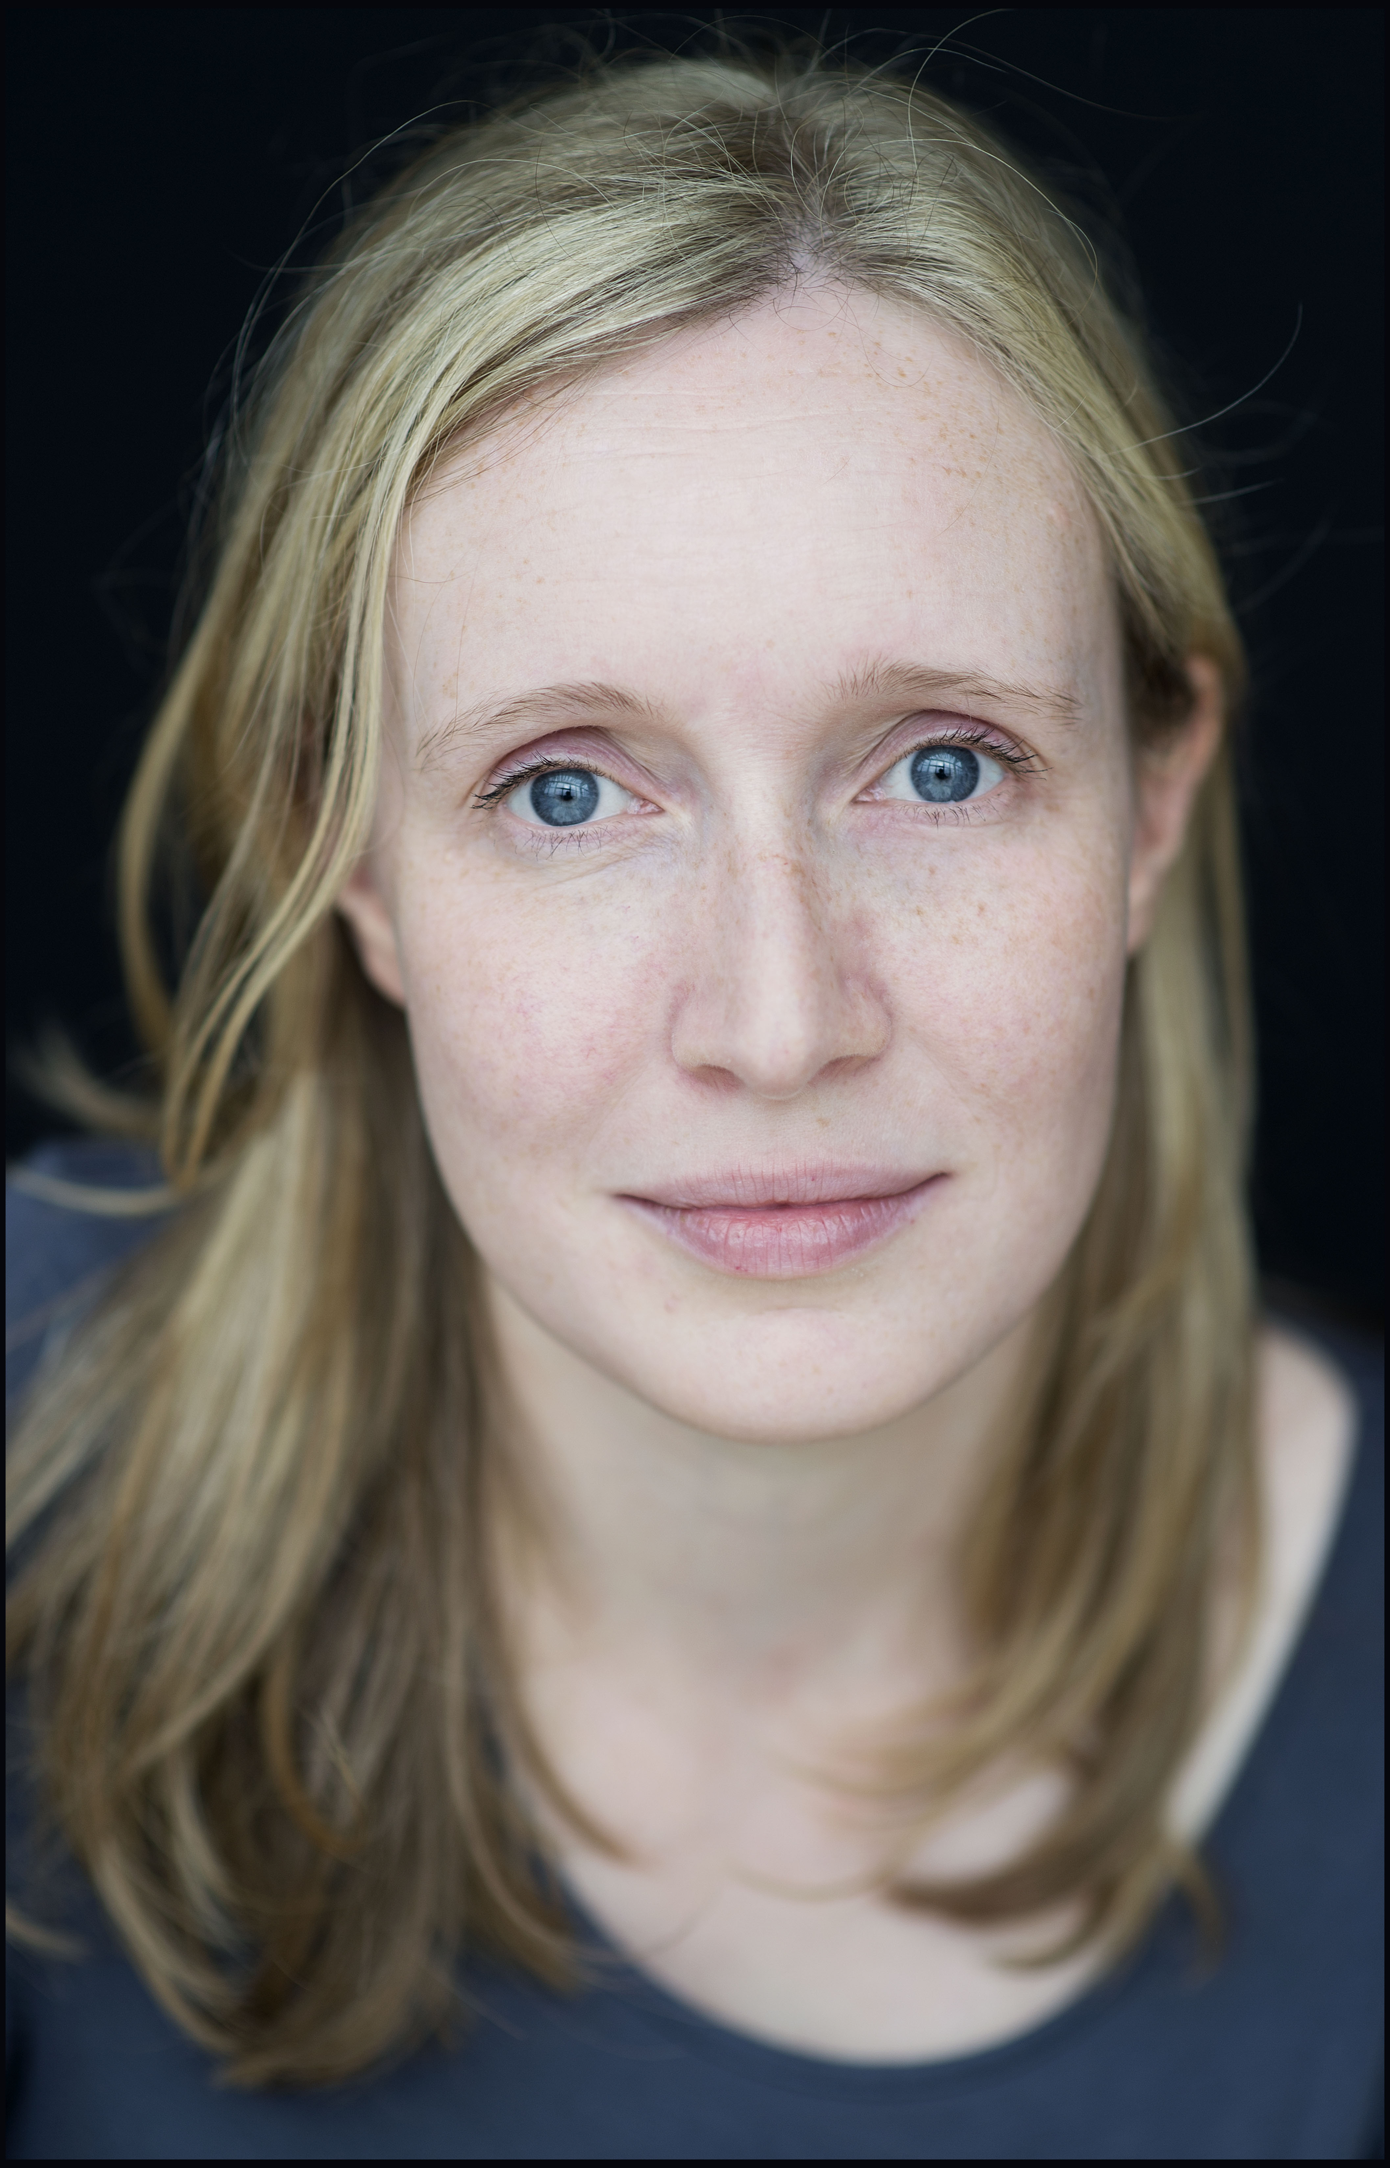

**Author, Lecturer**

Beatrice Hitchman is an author and creative writing lecturer. Her first novel, PETITE MORT, was nominated for the Desmond Elliott Prize, the Polari Prize, the Author's Club Best First Novel Prize, the HWA Debut Dagger and adapted as a Radio 4 Woman's Hour Drama starring Honor Blackman. Her short fiction has appeared in literary journals and magazines. She recently co-judged (with Philip Hensher) the Bath Spa 25-Word Novel flash fiction competition, whose prize was awarded by Jeremy Irons at the London Library in 2017.

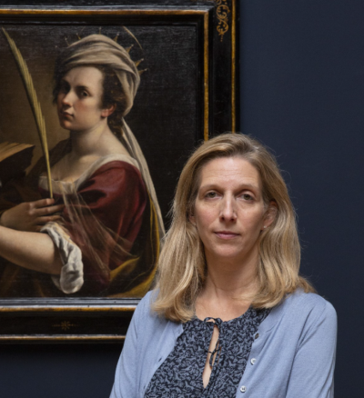**Letizia Treves**

**The James and Sarah Sassoon Curator of Later Italian, Spanish, and French 17th-century Paintings, The National Gallery, London**

Letizia has been Curator of Later Italian and Spanish Paintings since 2013, and was given the additional responsibility of French 17th-century Paintings in 2016. She joined the National Gallery following a long career in the Old Master Paintings Department at Sotheby’s, where she was a Senior Director and the principal worldwide specialist in Italian paintings. Since coming to the Gallery, Letizia has curated a number of exhibitions, notably Beyond Caravaggio (2016), Murillo: The Self Portraits (2018), Bartolomé Bermejo: Master of the Spanish Renaissance (2019) and, more recently, Bellotto: The Königstein Views Reunited (2021). In 2018 Letizia championed the National Gallery’s acquisition of Artemisia Gentileschi’s Self Portrait as Saint Catherine of Alexandria, the first painting by the artist to enter a public collection in the UK, and she was the curator of the much-acclaimed Artemisia exhibition (2020).

**FIRST PLACE**

**Janet Gray**

**North Tawton Afternoon WI, Devon Federation**

**The broken wheel**

Each day I look out at the faces of the people who stand before my image. I listen to those who know of me and my work; those who on their trip to the gallery stopped by the gift shop and bought their guide. I hear time again the story of my life- of how in a world where some women were often simply seen as objects or worse, not seen at all, I accomplished so much.

The gallery viewers discuss my portrait in hushed tones. There are those who see a warrior, proud and defiant, whilst others talk of martyrdom and sainthood. Those who are curious take time to read the passage printed below my frame. My life is fixed in a short paragraph between two dates; a momentary interest sparked before passing on.

There are those who will never stop, knowing nothing of me. They pass by my image on their way to other rooms in the gallery to marvel at popular images by artists more famous than me. My face is not one to entice some people and my modest pose and robe holds no titillation for those seeking suchlike.

Despite this, some people do stop as they are drawn in b my gaze and, as I look down on them, I hope they see the story I show to them in my pose.

My story is not unique. It is one that has been told many times by women who have been used in order to gratify another’s lust. I fought back; I survived and if they look carefully into my eyes, they will see it all reflected there.

How many of them see that kike the wheel I hold, I was broken; made not whole, my life changed forever in one action. My body raped, destroyed in a moment where power was concealed in a mask of passion I was left powerless, unable to recapture my innocence.

I survived as survival is instinctual, but as a survivor I was only half alive, anger and vengeance replacing the joy and hope of my youth. Despite this I tried to fight back with words, canvas, oil and brush.

I am not hard on those who do not see this; I worked hard to mask my pain and fear and to stand defiant and strong. I created a shell within which my pain lies heavy and waiting. You might ask for what do I wait?

To be seen and understood; I wait to hear the scream of those who, like me have this pain but a voice much louder than mine and can speak for me.

They will see. Those of who, like me survive abuse, **will** see. And from where I am captured in my portrait, our eyes will meet in a silent greeting of recognition. For that I wait, for someone to understand that despite all I achieved, despite all I created. I did this with part of me broken.

***(Initial Judging)***

*This one has a very unusual POV taken from the beginning. Here it would seem that the image of St C herself gazes out from the painting by AG (acknowledging explicitly that she is in a painting with a frame and caption) on to the world of contemporary art-gallery visitors and judges the world as it passes by. Slowly, this stance is revealed as a kind of metaphor for a lot of women’s roles more generally – that is, they appear with details visible before a world that doesn’t altogether regard them attentively, or with insight, or with much elevated interest; but rather stifled, framed and captioned. This is ingenious, if just a little over-determined in its final statements (by then the case is made, and this looks unneeded).*

***(Final Judging)***

*I found it ingenious that the author chose to write a piece of prose from the point of view of Artemisia inside the self-portrait, as if the painting were a living thing. She conveys the ambiguities of Artemisia’s stance and expression, acknowledging that every one of us has a very different, personal response to Artemisia’s story and to her work. Drawing connections between her own experiences and those of Artemisia and Saint Catherine, we are reminded that they are survivors, not victims, of abuse.*

**SECOND PLACE**

**Hazel Allen**

**Malham WI, North Yorkshire West Federation**

**Let me show you what a woman can do!**

I watch you, see you stare and scrutinise,

You know about my life, or think you do,

Singing my praise, but then you patronise.

“She has some talent for a woman who

Was married. With five children! She’s no saint!”

But scrape a little deeper, hear Catherine speak.

See the layers of pain beneath the paint.

I too have heard how men would call me weak.

I faced the challenges and I was strong.

Forced open doors, stood side by side with men.

Here, free and independent, I belong.

I will not let your rules be mine again.

I will not be held back, put in my place.

I can do this; you see it in my face.

|  |
| --- |
| ***(Initial Judging)***  *This entry stood out amongst a strong field for the simplicity and effectiveness of its diction. The author is achieving the considerable feat of making the work of poetry look easy, when of course, we know it's anything but - the reader is fluently drawn through the poem by the strength of its voice, the simple but elegant rhyme and rhythm scheme; there's a beautiful irony in the choice of the sonnet form to talk about oppression, but this does allow for the lovely turn at the end into defiant positivity. Although we're dramatising the point of view of the portrait, there's nothing clunky about this: the voice is smoothly integrated into the overall structure. By the time we got to the closing line, I was mentally cheering! Congratulations on a really excellent piece of work; confident, unshowy, beautifully crafted, this poem truly exemplifies 'what a woman can do' for me. I'm looking forward to reading more from this author.* Brava! |

***(Final Judging)***

*This poem is an empowering, subtle and succinct piece of writing which successfully weaves together Artemisia’s, Saint Catherine’s and the author’s experiences in just a few lines. Highly original, this poem met the brief perfectly, drawing inspiration from Artemisia’s self-portrait in the National Gallery.*

**THIRD PLACE**

**Romaine Barclay-Kim**

**Eglingham and Longhoughton with Boulmer WI, Northumberland Federation**

**Shout Your Truth in the Court of Man!**

“Bastardo! I should have cut his balls off! Write that down!”

The frail woman jabbed her bony finger at the paper. The younger woman grimaced as she continued to write. Her mother had never minced her words.

“Spying, always spying and leering at me with his mate. My father trusted him in the house as my art tutor! Ha! He could weasel his way in anywhere with his honeyed works dripping with lies and venom.”

She sighed, “Of course, he had me. I was so young, a virgin, but he said, “You are my bride in the eyes of God.” She contorted her face mimicking him, “My little darling, we shall be married soon.” Ha! Well that didn’t happen! The bastard was already married.”

She paused whilst remembering events, “My father did his best at the time. Took him to court. But did he suffer? No! I was the one who suffered! They nearly broke my bloody thumbs with their torture and then where would I have been? Women always suffer at the hands of men - just like dear Saint Catherine – tortured for telling the truth! The court should have stood up for me, an innocent girl, but instead I was shamed. It took all my strength to prove the truth.”

“Only one man came forward to protect my good name and my father felt that, now that I was ruined, he would be a good enough man for me to marry. He was kind but I did not love hime enough to stay shackled. My passion was my painting! I knew my work was as good if not better than any man’s and I proved it! We did alright girl, didn’t we?

Yes, Mamma,” she replied softly.

She looked directly at her daughter. “I could only tell my truth to the world in my paintings, but you my girl – you! I made sure you had an education. You can read and write. My father didn’t think a woman needed that! You have a freedom with your education. Use it!”

Her mother spoke angrily, “They called me the painter whore and tried to refuse me into polite society but I allowed them! Jealous! Jealous of my success!”

The young woman looked at her strong mother who had fought and negotiated her way through a man’s world, had established her own household and had given her a very different and easier life than her own. Mamma had painted for princes and dukes. So strong but so weak now as she lay on her bed.

“I am so proud of you Mamma,” she said.

Artemisia rallied and took her daughter’s hand.

“Take that pride and give it to your daughters and your daughter’s daughters. Paint your soul, write your thoughts, sing your heart’s music, dance your own dance! Most of all, shout your truth in the court of man! You can write that down too!”

***(Initial Judging)***

*What an incredibly vivid opening: a barnstormer! I loved the vivid tone on display in this imagined conversation between Gentileschi and her daughter. In this piece, Gentileschi seems somewhat embittered by her experiences, which was a breath of fresh air, perhaps gesturing to the idea that survivorship always comes at a price - although she rallies at the end. This piece also does a great job of allowing the character of Gentileschi to breathe; the conversation with the daughter feels authentic and emotional, rather than just being a vehicle for information about them. This was a very strong competition entry, and I hope the author continues to write.*

***(Final Judging)***

*A considerable amount of research clearly went into this piece, conveying Artemisia’s fiery spirit and giving her a very clear, energised voice. I particularly enjoyed the author imagining what Artemisia’s relationship would have been like with her daughter Prudenzia, whom she trained as a painter. It is reminiscent of the important historical novel by Lucia Lopresti (known by her pen name Anna Banti), published in 1947, which was the first piece of writing to explore Artemisia’s personal story and psychology.*

**HIGHLY COMMENDED**

**Suzane Simmons**

**Marlow Common WI , Buckinghamshire Federation**

**Let me show you what a woman can do!**

Purple Cottage

The Green

White Combe

Lancashire

My darling Connie,

I have had this postcard since I took you to the National Gallery several years ago, do you remember?

We went to see the exhibition of the work by the Italian painter Artemisia Gentileschi.

Women artists were rarely seen in her time but she was a successful court painter of the house of Medic. Can you believe that she even knew Galileo!

Anyway, your great grandmother Jessie admired Artemisia’s work because she was known for her feminist themes. You will no doubt know I’m sure, that 17th century women seldom held jobs let alone be revered for them. She painted many self-portraits and this one is of her as Catherine of Alexandria. Another impressive woman who was a noted scholar and converted many people to Christianity. So, here you have one strong, talented woman producing a magnificent portrait dressed as another accomplished woman.

Now my dear, you’ll be wondering what your old grandma is going on about. Well, let me tell you.

As you leave school, enter an exciting new phase of your life and find your path in this beautiful but bewildering and often unjust world, I want you to remember who you are.

Just look over your shoulder and you will see – generations of women who have always stood and fought for what they wanted and what they believed in – the right to choose and to be themselves. They are right behind you and, you’ll even recognise some of us.

You are Constantia Adela, named after your great, great grandmother. She would be so proud of you and in many ways you are much like her; determined and stron. Your school motto “Today’s students, Tomorrow’s successful women” will hold you in good stead as it did her and future generations of women in our family.

I am enclosing a medal that belonged to Adela. She was acknowledged as one of the first protesting women to go on hunger strike. It is a Hunger Strike Medal which was presented to her and others after their arrest and imprisonment. I think it is fitting that engraved on the back are the words “Let me show you what a woman can do”.

Take it, and the strength and determination of women who came before you, for those who will follow you, and go and live the life that you want.

Connie, you have a different surname but always remember that just like me, you are and always will be a Parkhurst.

With much love

Grandma Emmi

***(Initial Judging)***

*A lot of ingenuity in the structure of this one, and some subtleties too (I like the address using purple, green and white, for eg). There is a similar neatness in the exposition of the ‘facts of the case’ in the early section, framed with the more personal story of the letter writer. This bridges to naming the occasion for writing – the receiver’s coming of age moment in time – and the symbolic manner in which this receiver literally shares a name with a forebearer. All nice work in this. It concludes with a recognition that in order to grasp the future fully, one must understand as much as possible of the forces that contribute to that future – likewise, symbolized in the passing on of the medal. Clever work throughout here.*

***(Final Judging)***

*Though very different, entries no. 10 and no. 59 both addressed the very important issue of how knowledge and wisdom is passed on from women of one generation to the next, and that many of the issues faced by our predecessors are still very much ‘live’ issues today. Both were equally imaginative: no. 10 framed as a letter, drawing a subtle parallel between Artemisia and the trailblazers of the Suffragette movement*

**HIGHLY COMMENDED**

**Jane May**

**Wittenham WI, Oxfordshire Federation**

**Let me show you what a woman can do!**

Grandmother Astrid told of the night her knitting machine arrived, when the ship sailed scarlet against the blackness of the fjord and the bone-white evening sky, and the sailors unloaded the box onto the quay. Excitement mounted in her warm kitchen as the shiny mechanism and sturdy trestle emerged from sweet-smelling wood shavings. The machine had cost all her savings, but brought independence and a respected livelihood.

Black, white, red: using colours and patterns of her northern home, she made traditional garments in a new way, sturdy jumpers for men on the whaling ships, mittens from oiled wool against the freezing cold, or lacy white gloves for brides.

“But terrible times came, when foreign soldiers occupied our land. Some older ones were less harsh and violent, but pretty girls avoided the younger boys, whose intentions were not always honourable.”

Astrid worked late knitting clothes to protect against the bitter snow, knowing it was forbidden to burn lamps past midnight, but garments were badly needed. Next day, icy fingers of fear ran down her spine as a young soldier banged at her window. She had seen him in the fish market, strutting up to girls on the stalls, who pulled their shawls close and drew away. “Your lamps!” he shouted, “ If you disobey our rules, we will stop your work and food rations.” Instantly she perceived he was little more than a shivering boy, his uniform unsuited for winter, whose chapped hands were swollen and red. Reaching across her work table for the greasy salve she used herself, she selected a pair of freshly-knitted gloves from the pile. “I am sorry” she said. “I did not understand. It will not happen again. Please take these for your poor hands.” To her relief, he nodded brusquely in acceptance and marched away.

Soon came dreadful news: villagers would be evacuated by sea, while church and houses were laid waste. Leaping red flames reduced everything to black ash in the burning, while folk secretly buried precious items, hoping to return. Astrid made a bolder choice, pulling her boxed machine by sledge down to the waiting ship. Soldiers, including the young man, were checking villagers aboard; surplus luggage was thrown into the fjord. “You will not need this” said one. “Over it goes”. “Not so fast” said her visitor. “This is an important industrial machine, which is of use to us. Load it as cargo, or there may be trouble.” Astrid mounted the gangplank with pounding heart, hardly daring to breathe. The ship passed slowly towards the dark ocean as snow fell. Through the flakes, she saw a flash of black, white and red gloves as the young man waved, or maybe saluted, in her direction.

“So, grand-daughter, let me show you what a woman can do. As clever craftswoman re-knit old yarns into fresh clothes, so a woman may work the treads of fortune in a different way, weaving a brave new pattern for the future.”

***(Initial Judging)***

*This engaging story distinguished itself by its fresh approach to the prompt. It was a pleasure to meet Grandmother Astrid and spend time in the frosty Northern setting, beautifully animated by colour detail and descriptive language - 'the bone-white evening', 'the blackness of the fjord.' These colours recur symbolically at the end of the story, in the red and black of the fire, and when Astrid turns out to be rescued by a prior act of kindness. I loved the simplicity of the story, well told, and the analogy of the continuity of weaving histories. There was a confident voice at work here, elegant writing, and an intriguing story full of peril. Highly commended! I hope we get to see more by this author.*

***(Final Judging)***

*Entry no. 72 took the phrase ‘Let me show you what a woman can do’ as its inspiration, rather than the painting in the National Gallery (as set out in the brief), but it was perhaps the best piece of writing of all the entries – a very moving and evocative short story that deserves special praise.*

**HIGHLY COMMENDED**

**Jenny Cawthorne**

**Wellingore WI, South Lincolnshire Federation**

**Let me show you what a woman can do!**

How to present these pictures by Artemesia, plus their Connotations, to Year 12?..........

I contemplate this as I frustrated peg out washing …. Worst thing that happened to ME today? Someone, left a tissue in his pyjama pocket! I’m fortunate, others, not so ………………………………………………………….

Artemesia furiously swept the brush across the gesso surface, anger infecting every stroke, pure venom in her desire to avenge defilement and injustice suffered by others of her sex.

Hence previous subjects; Judith beheading Holofernes and similarly grotesque subjects of horrifying realism. However, more subtle current painting could still add resonance to her continued fight against male dominance and oppression. She stood proud in a man’s world; a rarity in 1615. Angry tears spilled, as she painted, not of self pity; more powerful emotions. Her own face as “St. Catherine ‘emerged from the canvas, challenging the voyeur. Men could destroy ‘Catherine’ for her faith in this world, but NOT the next.

Catherine is calm, dignified, and all seeing; her devout faith for which she was being executed, giving courage. Artemesia calmed as she painted, knowing that with each creation ………. Through a holistic appreciation of human nature, realism, physicality; simultaneously conveying sexual and spiritual mood, revelation, and a painterly use of chiaroscuro, she could give a message………..

‘Morning! Todays subject; ‘Artemesia Gentleschi (1593-1653)…………….

Let me show you what a woman DID through wielding a paintbrush, against oppression……………………………

‘How do you spell Arte….Miss?’

‘Look at your notes……….. a precociously gifted artist, formidable personality, lived a life of independence (rare for women in 1600’s). The dark subjects she often portrayed, full of eroticism, sexual physicality, brutality, were influenced by appalling circumstances. Aged 19, she was reaped by her father’s friend Agostini Tassi. During questioning, she was tortured. Tassi; was later acquitted. See examples of violent, blood thirsty subjects? She is capable of a gentler, yet strong composition too in this painting of St Catherine awaiting torture on a spiked wheel, for her Christianity……………………

What ‘ism’ has influenced Artemesia’s technique?’

‘Lisa?’

‘Caravaggism?’

‘Thank you! Explain?’

‘Chiarascuro…....extremes of dark and light to dramatic effect’

‘Yes!’

‘Now, revenge…………….was it sweet for Artemesia? ………………………..

Michelle screwed her eyes up, to prevent tears spilling onto her Art History notes, she jabbed at the paper with her biro as she scribbled…….. rape, injustice. The pressure of pen indenting the paper. She, feeling grazes left by the brick wall through the cotton of her school shirt. The blood and dirt hastily hidden under the navy cardigan. She gazed at the craft knife on her desk until it doubled. What she’d like to do to him. How dare he debase her! A man can do THIS to a woman. A woman cannot do THIS to a man!

She shivered, gritted her teeth, humiliated, ravaged and distraught for her loss…………………….

Her assailant, confident, full of himself, swaggered off…………… free, oblivious, unscarred!

The Art Room emptied…………….

She looked up. ‘Miss, I need a word, please?’

***(Initial Judging)***

*As a fellow educator, I loved the framing device here of a teacher wondering how best to engage their class on a given topic! The snippets of conversation in the classroom felt very relatable, and also added a welcome touch of humour. The tale took a dark turn with Michelle's experience, and this was very well expressed through sensory detail - the grazes left by the brick wall - and I loved the rousing conclusion, drawing the modern-day and Gentileschi threads together and demonstrating that real impact and change are possible through women educating each other. This was vivid and effective writing, showing a range of women's experience in a light touch but nonetheless affecting way, and a strong competition contender. I hope the author will continue to develop their creative practice.*

***(Final Judging)***

*This entry addressed the very important issue of how knowledge and wisdom is passed on from women of one generation to the next, and that many of the issues faced by our predecessors are still very much ‘live’ issues today. This was very imaginative. This entry is set in a classroom, seen from both the perspective of a teacher and her pupils.*