

**Notes and Rules.**

**Entrance Fees: £3.00 per class. Prizes: 1st - £20 2nd - £10**

**All classes; A maximum of one entry per member per class is allowed.**

**Entry forms to reach Surrey Federation Headquarters by Friday 23rd April 2021.**

**All competition items to be delivered or posted to the Surrey Federation**

**Headquarters for judging by the following date;**

**Thursday 27th May, 2021 between 10.00am – 12.00 noon.**

**No entries will be accepted after this date.**

**The Surrey Federation of WI's cannot be responsible for any items on display at the Surrey County Show and would suggest that any valuable items be adequately insured by the exhibitor.**

**All entries must have been made within the previous 24 months.**

**WI rules apply to all exhibitors. All finishing, presentation, marking and guidance can be found in the handbook "On with the Show" (OWTS 2015) available from your secretary or online via My WI. Further information regarding the presentation of exhibits can be obtained from Meriel Sexton (merielsexton@hotmail.com). Each Judge's decision is final.**

**Surrey County Show 2021**

**Stoke Park, Guildford,**

**Monday, 31st May 2021**

**Welcome to the 2021 Surrey Show schedule from the Surrey Federation of WI's. We have carried over the theme and schedule from 2020 for this year's show; "Develop your Skills".**

**We have included two additional classes and are allowing entries to have been made within the previous 24 months, to allow for inclusion of items made for the 2020 show.**

**Judging will take place at Surrey Federation headquarters after the relevant closing dates; please see the notes and rules section for further information.**

**Winners will be informed if they have been awarded 1st, 2nd or Highly Commended after the show.**

**Mark cards and certificates for 1st, 2nd and Highly Commended will be posted from Surrey Federation Headquarters. If you attend the Show, your entry and certificate can be collected in person after 5.00pm (no later than 6.00pm). No exhibit may be removed before 5.00pm on the day of the Show.**

**Items that are not collected on the day will be returned to Surrey Federation headquarters for your collection by arrangement. However perishable items, cakes, will be disposed of as they will have been on display in a very warm environment and would be a health risk.**

# Surrey County Show 2021.

# Theme; Develop your Skills

**A Victoria Sandwich Cake made following the given recipe. (See opposite)**

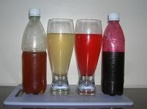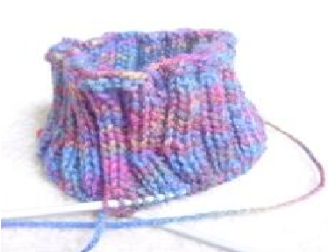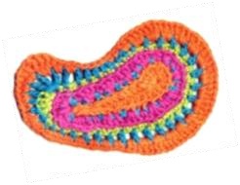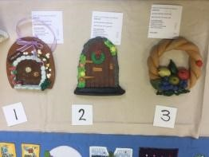

**A Labelled Bottle of Cordial. Bottle size approx 300ml. Please include your recipe.**

**A Hand Knitted Item. Please include the pattern**

**if you use one.**

**A Crocheted Item. Please include the pattern if**

**you use one**

**A Salt Dough Model**

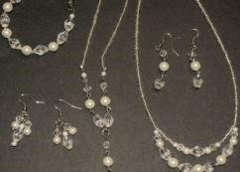**(no larger than 30cm X 30cm X 30cm)**

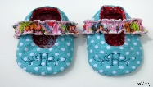**An Item of Jewellery in any medium. (necklace, bracelet, earrings or brooch) *No precious metals/ stones should be used.***

**An item as a gift for a Baby. Any medium.**

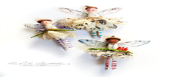

[This Photo](http://www.theidearoom.net/2016/07/clothespin-craft-ideas.html) by Unknown Author is licensed under [CC BY-NC-ND](https://creativecommons.org/licenses/by-nc-nd/3.0/)

**2 or more Peg Dolls made from dolly pegs,**

**Decorated and/or dressed.**

**Accessories allowed.**

**Reference should be made to the following pages in "On With the Show" 2015.**

|  |  |  |
| --- | --- | --- |
| **Class** |  | **OWTS reference** |
| **1** | **A Victoria Sandwich** | **Page 104,107,109** |
| **2** | **Bottle of Cordial** | **Page 135** |
| **3** | **Knitted Item** | **Page 54, 55, 78** |
| **4** | **Crocheted Item** | **Page 54, 55, 65** |
| **5** | **Salt Dough Model** | **Page 92** |
| **6** | **Item of Jewellery** | **Page 57,72,87** |
| **7** | **Gift for Baby** |  |
| **8** | **Dolly Clothes Pegs** |  |

**Victoria Sandwich Recipe Ingredients:**

* **3 medium eggs weighed in their shells (probably 170g/6oz)**
* **The weight of eggs in butter/soft margarine**
* **The weight of eggs in caster sugar**
* **The weight of eggs in self-raising flour**
* **Raspberry jam to fill – homemade/good quality**

**Set oven to 180C/160C (fan)/ gas mark 4.**

**Grease and line the bottom of two 20cm/8’’ sandwich tins. Cream butter/margarine and sugar. Beat the eggs then gradually add to the mixture beating well each time. Sieve the flour and fold into the mixture with a metal spoon. Divide equally between the two tins and bake for 25-30 minutes. They are ready when they are golden, shrunk from the side of the tin and spring back when touched. Remove cakes from tins. When cold, fill with raspberry jam. Finish with a light dusting of caster sugar.**

Entry Form - Surrey County Show 2021

## Theme; Develop your Skills

**WI:**

**Name:**

**Address:**

**Phone number**

**Email address:**

**Entry Forms to reach Surrey Federation Headquarters by Friday 23rd April 2021. Cheques should be made payable to "SFWI", with your name and class number on the reverse. Please enclose an s.a.e. (A5 size envelope) if you wish to receive your scorecard and judges' comments.**

|  |  |  |  |
| --- | --- | --- | --- |
| **Class** |  | **Fee** | **£** |
| **1** | **A Victoria Sandwich** | **£3** |  |
| **2** | **A Bottle of Cordial** | **£3** |  |
| **3** | **A Knitted Item** | **£3** |  |
| **4** | **A Crocheted Item** | **£3** |  |
| **5** | **A Clay Dough Model** | **£3** |  |
| **6** | **A Piece of Jewellery** | **£3** |  |
| **7** | **Baby Love** | **£3** |  |
| **8** | **Off the Clothes Line** | **£3** |  |

Entry Form - Surrey County Show 2021

## Theme; develop your Skills

**WI:**

**Name:**

**Address:**

**Phone number**

**Email address:**

**Entry Forms to reach Surrey Federation Headquarters by Friday 23rd April 2021. Cheques should be made payable to "SFWI", with your name and class number on the reverse. Please enclose an s.a.e. (A5 size envelope) if you wish to receive your scorecard and judges' comments.**

|  |  |  |  |
| --- | --- | --- | --- |
| **Class** |  | **Fee** | **£** |
| **1** | **A Victoria Sandwich** | **£3** |  |
| **2** | **A Bottle of Cordial** | **£3** |  |
| **3** | **A Knitted Item** | **£3** |  |
| **4** | **A Crocheted Item** | **£3** |  |
| **5** | **A Clay Dough Model** | **£3** |  |
| **6** | **A Piece of Jewellery** | **£3** |  |
| **7** | **Baby Love** | **£3** |  |
| **8** | **Off the Clothes Line** | **£3** |  |