LISTEN SPEAK INSPIRE

A CONFIDENCE BOOST
WORKSHOP

Would you like to make an announcement at your WI or thank a speaker without your legs shaking or your face flushing? Would you like to feel more confident in standing up in front of your WI? If the answer is YES then this workshop is for YOU.
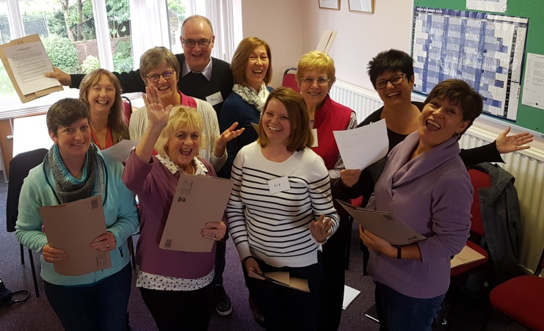
We will help you learn:
- Relaxation skills
- Breathing techniques and voice skills
- How to introduce and thank speakers
- How to make an announcement

We guarantee you will go away with renewed confidence and less fear of speaking in front of others.
Open to all members – but places are limited, so sign up today choosing one of the following dates at a Federation near you:
Derbyshire 21 March 2020
Lincolnshire 25 April 2020
Surrey 09 June 2020
Dorset 08 July 2020
Herefordshire 30 September 2020

Workshops begin at 10am and finish at approximately 3.30 pm.
Cost is just £20.00 per person to include refreshments and a light lunch.
Cheques payable to NFWI or Bank transfer (BACS).

Application forms can be obtained from the NFWI Unit, your Federation Secretary or downloaded from My WI.

Please send your completed application form to Elaine Smith, Accreditation Officer, NFWI Unit, Denman College, Marcham, Abingdon Oxon OX13 6NW or email e.smith@nfwi-unit.org.uk
Telephone: 01865 391 788 ext 3281.

