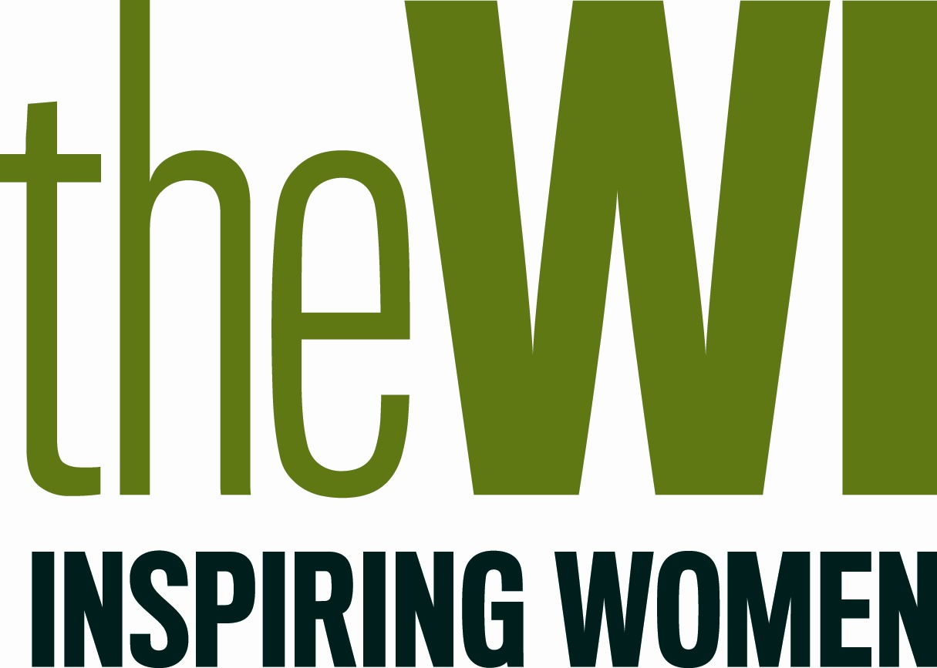
Elizabeth Bell Challenge 2021/2022
Inspiring Women, now and always!

Individual Entry Form

- Records can be displayed in any form – diary, scrapbook, video, presentation etc. WIs are encouraged to be creative and include as much information as possible within their finished entry.
- Finished entries must be no larger than A3.
- Any photographs used within the record must be the original work of the WI and taken between 1 January – 31 December 2021. Filtered or digitally enhanced images are acceptable.
- Consent must be given from all individuals that can be identified in any photographs. If there are children under 18, please ensure that consent is given from either a parent or guardian.
- WIs are required to follow government guidance, nationally and locally, at all times.
- The compilation of the final entry must be managed appropriately and in line with the government guidance in place at the time.
- A label bearing the name of the WI and federation must be visible on the back of the entry.
- Only one entry per WI.
- Overall standard and creative design of finished entry will be taken into consideration when judging, however Judges will be looking for WIs who have demonstrated success in engaging current and recruiting new members, in accordance with the WI strategic objectives:

The details given below will be used by the NFWI in all communication.

Full name:
Address:
Telephone:
Mobile:
Email:
WI:
Federation:

I agree that the NFWI shall have the right to use our entry in WI Life, on the NFWI website or other social media sites, as appropriate.

SIGNED: .............................................................. DATE: ......................................................

